


Policies

Safeguarding children's policy

Current Version: | 1.1 | Date of Update: | August 2026
Updated by: | Will Goode (Director of Operations)
SLT Policy Owner: | Will Goode | Policy Group: | Operations
Last Full Review: | August 2026 | Next Review Due: | February 2027
Policy Implemented: |  | 31st March 2025
Replaces previous policies: |  | n/a
If you have any queries in relation to this policy, please speak to your line manager.

Please Note: This is a controlled document. Always use the current version on INsite. Do not save or print copies, as they may be outdated.

Safeguarding Children - Policy and Procedure
OUTLINE
Purpose: The purpose of this policy is to protect children and young people who receive our services and to provide, employees and volunteers with the overarching principles that guide our approach to safeguarding.
Any reference to clients applies to all clients, tenants and residents.
Scope: This policy applies to all employees, volunteers, and anyone working on behalf of our organisation.
Definition of a Child
For the purposes of this policy, a child is any person under the age of 18 years, in accordance with the Children Act 1989 and Working Together to Safeguard Children.
This definition applies regardless of a young person's circumstances, level of independence, accommodation status, educational placement or whether they are living away from home.

Policy Compliance
This policy is mandatory for all employees, volunteers, agency workers, contractors, students, Board members and anyone working on behalf of Inspire North.
All individuals covered by this policy must:
- Read and understand this policy and associated safeguarding procedures.
- Complete safeguarding training at the required frequency.
- Comply with the requirements contained within this policy at all times.
- Confirm their understanding of safeguarding responsibilities through induction, supervision, training and policy acknowledgement processes.
Failure to comply with this policy may result in disciplinary action, termination of engagement, or referral to relevant professional or statutory bodies where appropriate.

Legislative Framework: This policy has been drawn up on the basis of law and guidance that seeks to protect children, namely:
- Children Act 1989 and 2004
- United Nations Convention on the Rights of the Child 1991
- Data Protection Act 2018
- Working Together to Safeguard Children 2018
- Keeping Children Safe in Education 2020
- The Safeguarding Vulnerable Groups Act 2006
Safeguarding children in England is governed by a comprehensive set of laws, regulations, and statutory guidance aimed at protecting children from harm and promoting their welfare. Here is an overview of the key legislation and statutory guidance relevant to safeguarding children in England:

Key Legislation
- Children Act 1989
This act provides the legal framework for the care and protection of children in England. It emphasizes the welfare of the child as the paramount consideration in all decisions about their upbringing.
- Children Act 2004
This act builds on the 1989 Act and places a duty on local authorities and their partners to cooperate to improve the wellbeing of children and to make arrangements to ensure that their functions are discharged having regard to the need to safeguard and promote the welfare of children.

- Safeguarding Vulnerable Groups Act 2006
This act provides the framework for the vetting and barring scheme to ensure that individuals who are deemed unsuitable to work with children and vulnerable adults are not able to do so.

- Children and Social Work Act 2017
This act strengthens the framework for safeguarding children, introduces the role of the Child Safeguarding Practice Review Panel, and promotes improvements in the
quality of social work.

- Working Together to Safeguard Children (2018)
This statutory guidance sets out the legal requirements and expectations on individual services to safeguard and promote the welfare of children. It provides a clear framework for Local Safeguarding Children Boards (LSCBs), social workers, health professionals, police, and other practitioners to work together.

Supporting Regulations and Statutory Guidance
- Keeping Children Safe in Education (KCSIE)
This guidance is issued by the Department for Education and sets out the legal duties that schools and colleges must follow to safeguard and promote the welfare of children and young people.

- The Care Act 2014
While primarily focused on adults, this act includes provisions for transition from children to adult services and has implications for safeguarding young people.

- Sexual Offences Act 2003
This act consolidates and updates the law relating to sexual offences, with specific provisions for protecting children from sexual exploitation and abuse.
- Education Act 2002
This act places a duty on local education authorities, governing bodies, and proprietors of independent schools to make arrangements to safeguard and promote the welfare of children.
- Serious Crime Act 2015
This act includes provisions to protect children from female genital mutilation (FGM), including the introduction of FGM Protection Orders.
- Department of Education - Guide to the Supported Accommodation Regulations including Quality Standards 2023

Local Safeguarding Arrangements
- Local Safeguarding Children Boards (LSCBs)
These boards were established under the Children Act 2004 to coordinate local efforts to protect and promote the welfare of children. Following the Children and Social Work Act 2017, LSCBs are being replaced by new safeguarding partner arrangements involving local authorities, health services, and the police. An A-Z of LSCBs can be found here: https://www.safecic.co.uk/scb-england
- Child Safeguarding Practice Review Panel
This panel reviews serious child safeguarding cases which raise issues of importance in relation to the safeguarding and promotion of the welfare of children in England.
These laws and guidelines form a robust framework for safeguarding children, ensuring that all agencies and professionals involved in the care and protection of children are working together effectively to prevent abuse and neglect.

- Inspire North Safeguarding Children Policy Statement

  - Inspire North is fully committed to safeguarding and promoting the welfare of all children and young people. It recognises its responsibility to take all reasonable steps to promote safe practice and to protect children from harm, abuse and exploitation. Inspire North acknowledges its duty to act appropriately to any allegations, reports or suspicions of abuse.

  - Children are best protected when professionals are clear about what is required of them individually, and how they need to work together. ‘Working Together to Safeguard Children 2018 provides a statutory framework for inter-agency working and places a responsibility on local authorities, Clinical Commissioning Group(s) (CCG) and the police to working in partnership to protect children. Alongside this, Working Together guidance identifies all agencies, including charities, as playing a role in safeguarding children. https://www.gov.uk/government/publications/working-together-to-safeguard-children--2

  - Inspire North requires all its employees to work together to develop an ethos which embraces difference and diversity and respects the rights of children, young people and adults.

  - In implementing this policy Inspire North will:

    - Ensure that all employees understand their legal and moral responsibility to work to safeguard and promote the welfare of children;

    - Ensure that all employees understand their responsibility to work to the processes that are detailed in the organisation Safeguarding Children Procedures and work at all times towards maintaining high standards of practice;

    - Ensure that all employees are aware of local safeguarding children’s boards interagency safeguarding procedures and are confident that they are working within these guidelines.

Please note: These procedures should be accessed online to ensure the most up to date version is referred to.

Links to Local Safeguarding Procedures:

CALDERDALE:

https://safeguarding.calderdale.gov.uk/children-and-young-people/

COUNTY DURHAM:

Darlington
https://www.darlington-safeguarding-partnership.co.uk/professionals/working-with-children/concerned-about-a-child-how-to-report-a-concern/

Durham
http://www.durham-scp.org.uk/

NORTH YORKSHIRE:
(includes Craven, Harrogate, Richmond, Ryedale & Scarborough)
https://safeguardingchildren.co.uk/children-young-people/

Redcar and Cleveland
https://www.redcar-cleveland.gov.uk/children-and-families-services/concerns-about-a-child

SOUTH YORKSHIRE:

Doncaster
https://www.doncaster.gov.uk/services/schools/children-s-services-delivering-social-care-and-safeguarding-to-children-young-people-and-families

Rotherham
https://www.rscp.org.uk/

Sheffield
https://www.safeguardingsheffieldchildren.org/

WEST YORKSHIRE:

Leeds
https://www.leedsscp.org.uk/About-us

Kirklees
http://www.kirkleessafeguardingchildren.co.uk/procedures-guidance.html

Bradford
https://www.saferbradford.co.uk/children/

Wakefield
https://www.wakefieldscp.org.uk/

    - Ensure that all employees understand their duty to report any concerns they have about a child, or a worker’s conduct towards a child, to their line manager and in turn to the organisation “named person” for child safeguarding, (hereafter called “responsible director”);

    - Ensure that the Designated Safeguarding Officer understands their responsibility to ensure any safeguarding or child welfare concerns are referred to the statutory child safeguarding agencies (i.e. Police and/or Children and Young People’s Social Care);

    - Ensure that all safeguarding or child welfare concerns, alerts or referrals are reported to Care Quality Commission (CQC), Office for Standards in Education, Children’s Services and Skills (OFSTED) and/or Adult Social Care (ASC) as required by legislation or contractual obligation.

    - Ensure that any procedures relating to the conduct of employees are implemented in a consistent and equitable manner;

    - Provide opportunities for all employees to develop their skills and knowledge in relation to the welfare and safeguarding of children;

    - Ensure that children are enabled to express their ideas and views on a wide range of issues and will have access to the organisation Complaints, Compliments and Feedback Procedure;

    - Ensure that parents/carers are encouraged to be involved in the work of the organisation and, when requested, have access to all guidelines and procedures;

    - Endeavour to keep up-to-date with national developments relating to the welfare and safeguarding of children and young people.

    - Ensure that the Inspire North Board are aware that they are ultimately accountable for all that happens within the organisation and are knowledgeable around the needs of the children utilising our services.

- Introduction

  - Inspire North employees come into contact with children in a variety of ways:

    - Young adults of 16-18 years of age who may be part of a service akin to the Inspire North OWL service but are still classed as children under The Children Act 1989, or in the case of Inspire North’ Early Intervention in Psychosis Service (aspire), 14-18 years of age.

    - Clients of the Organisation who have children.

    - Children of people known to Inspire North clients.

  - For the purposes of this document a child is defined as anyone under the age of 18 years.

  - Safeguarding and promoting the welfare of children is defined as:

    - Protecting children from maltreatment;

    - Preventing impairment of children's health or development;

    - Ensuring that children grow up in circumstances consistent with the provision of safe and effective care;

    - Taking action to enable all children to have the best outcomes.

  - These procedures have been designed to safeguard and promote the welfare of any child who is known to services within Inspire North. The procedures recognise that child safeguarding can be an emotive subject and understand that some employees may find it a challenging area. However, it is important that employees respond appropriately to child safeguarding and welfare issues and are aware of their responsibilities.

  - Inspire North is committed to the belief that safeguarding and promoting the welfare of children is everybody’s responsibility and that these guidelines will enable all employees and volunteers to act appropriately to any concerns that arise in respect of a child.

  - Inspire North is committed to the fair treatment of its employees, potential employees or users of its services, regardless of race, gender, religion, sexuality, responsibilities for dependants, age, physical/mental disability or offending background as long as this does not present a risk to children and vulnerable adults and/or negatively impact the organisation.

- Key principles of Safeguarding
Our approach to safeguarding is based on the following principles:
- The welfare of the child is paramount.
- All children, regardless of age, disability, gender, racial heritage, religious belief, sexual orientation, or identity, have the right to equal protection from all types of harm or abuse.
- Working in partnership with children, young people, their parents, carers, and other agencies is essential in promoting young people's welfare.

  - Safeguarding is everyone’s responsibility. For services to be effective each professional and organisation should play their full part; and

  - Use a child-centred approach: for services to be effective they should be based on a clear understanding of the needs and views of children.

  - Ensure the young people we support understand their right to be safeguarded. A child friendly version of this policy has been created to assist with this (Appendix 6).

- Definitions

  - Abuse: A form of maltreatment of a child. Somebody may abuse or neglect a child by inflicting harm, or by failing to act to prevent harm. Children may be abused in a family or in an institutional or community setting by those known to them or, more rarely, by others (e.g. via the internet). They may be abused by an adult or adults, or another child or children.

  - Physical Abuse: A form of abuse which may involve hitting, shaking, throwing, poisoning, burning or scalding, drowning, suffocating or otherwise causing physical harm to a child. Physical harm may also be caused when a parent or Carer fabricates the symptoms of, or deliberately induces, illness in a child.

  - Emotional Abuse: Is the persistent emotional maltreatment of a child such as to cause severe and persistent adverse effects on the child’s emotional development. It may involve conveying to children that they are worthless or unloved, inadequate, or valued only in so far as they meet the needs of another person. It may include not giving the child opportunities to express their views, deliberately silencing them or “making fun” of what they say or how they communicate. It may feature age or developmentally inappropriate expectations being imposed on children. These may include interactions that are beyond the child’s developmental capability, as well as overprotection and limitation of exploration and learning, or preventing the child participating in normal social interaction. It may involve seeing or hearing the ill-treatment of another. It may involve serious bullying, (including cyber- bullying) causing children frequently to feel frightened or in danger, or the exploitation or corruption of children. Some level of emotional abuse is involved in all types of maltreatment of a child, though it may occur alone.

  - Sexual Abuse: Involves forcing or enticing a child or young person to take part in sexual activities, not necessarily involving a high level of violence, whether or not the child is aware of what is happening. The activities may involve physical contact, including assault by penetration (for example, rape or oral sex) or non- penetrative acts such as masturbation, kissing, rubbing and touching outside of clothing. They may include non-contact activities, such as involving children in looking at, or in the production of, sexual online images, watching sexual activities, or encouraging children to behave in sexually inappropriate ways, or grooming a child in preparation for abuse (including via the internet). Sexual abuse is not solely perpetrated by adult males. Women can also commit acts of sexual abuse, as can other children.

  - Domestic Abuse: Domestic abuse is any type of controlling, bullying, threatening or violent behaviour between people in a relationship. But it isn’t just physical violence – domestic abuse includes emotional, physical, sexual, financial or psychological abuse Domestic abuse can seriously harm children and young people. Witnessing domestic abuse is child abuse, and teenagers can suffer domestic abuse in their relationships. Where young people are identified of instigators of domestic abuse, interventions should focus, where safe and appropriate, on prevention and support rather than criminal justice routes.

  - Online Abuse: Online abuse is any type of abuse that happens on the web, whether through social networks, playing online games or using mobile phones. Children and young people may experience cyberbullying, grooming, sexual abuse, sexual exploitation or emotional abuse.

    - Children can be at risk of online abuse from people they know, as well as from strangers. Online abuse may be part of abuse that is taking place in the real world (for example bullying or grooming). Or it may be that the abuse only happens online (for example persuading children to take part in sexual activity online).

    - Children can feel like there is no escape from online abuse – abusers can contact them at any time of the day or night, the abuse can come into safe places like their bedrooms, and images and videos can be stored and shared with other people.

  - Neglect: Is the persistent failure to meet a child’s basic physical and/or psychological needs, likely to result in the serious impairment of the child’s health or development. Neglect may occur during pregnancy as a result of a range of issues, for example, maternal substance abuse and/or domestic abuse. Once a child is born, neglect may involve a parent or Carer failing to:

    - provide adequate food, clothing and shelter (including exclusion from home or abandonment);

    - protect a child from physical and emotional harm or danger;

    - ensure adequate supervision (including the use of inadequate care-givers);

    - ensure access to appropriate medical care or treatment.

    - It may also include neglect of, or unresponsiveness to, a child’s basic emotional needs.

  - Female Genital Mutilation (FGM): FGM refers to procedures that intentionally alter, mutilate or cause injury to the female genital organs for non-medical reasons. FGM is medically unnecessary and can have serious health consequences, both at the time it is carried out and in later life.

    - FGM is illegal in the UK. The Female Genital Mutilation Act 2003 strengthened existing law to make it an offence to arrange for a child to be taken abroad for FGM, and for UK nationals or permanent UK residents to abet, counsel, procure or undertake FGM abroad, even in countries where the practice is legal.

    - The Serious Crime Act 2015 (guide) extends this protection to girls under the age of 18 who are ‘habitually resident’ (or on short temporary stays) such as students and refugees. The Serious Crime Act also creates a new offence of failing to protect a girl from FGM. If an offence of FGM is committed against a girl under the age of 16, each person who is responsible for the girl at the time the FGM occurred will be liable under this new offence where the maximum penalty is seven years’ imprisonment, a fine, or both. A ‘responsible’ person will have parental responsibility with the girl and frequent contact. Regulated professionals in health and social care professionals and teachers in England and Wales have a duty to report 'known' cases of FGM in under 18s which they identify in the course of their professional work to the police. Practitioners should complete the West Yorkshire Police FGM reporting form (Appendix 4) and email it to: cib@westyorkshire.pnn.police.uk. Please note, this form is the same for all services in West Yorkshire.

For all other geographical areas, reports can be made to 101, the non-urgent police contact number.

  - Child Trafficking and Modern Slavery: children are recruited, moved or transported and then exploited, forced to work or sold. Many children are trafficked into the UK from abroad, but children can also be trafficked from one part of the UK to another. Children are trafficked for:

    - child sexual exploitation

    - forced marriage

    - domestic servitude such as cleaning, childcare, cooking

    - forced labour in factories or agriculture

    - criminal activity such as pickpocketing, begging, transporting drugs, working on cannabis farms, selling pirated DVDs and bag theft.

  - Child Sexual Exploitation (CSE): CSE is a type of sexual abuse. Children in exploitative situations and relationships receive something such as gifts, money or affection as a result of performing sexual activities or others performing sexual activities on them.

    - Children or young people may be tricked into believing they're in a loving, consensual relationship. They might be invited to parties and given drugs and alcohol. They may also be groomed online.

    - Some children and young people are trafficked into or within the UK for the purpose of sexual exploitation. Sexual exploitation can also happen to young people in gangs.

  - Child in Need: A child shall be taken to be “in need” if:

    - They are unlikely to achieve or maintain or to have the opportunity of achieving or maintaining, a reasonable standard of health or development without the provision for them of services by a Local Authority;

    - Their health or development is likely to be significantly impaired, or further impaired, without the provision for them of such services;

    - They are disabled.

  - Early Help: is the term used by agencies to describe an approach to providing support to potentially vulnerable children, young people and their families as soon as problems start to emerge or when there is a strong likelihood that problems will emerge in the future. The purpose of Early Help is, through prompt and targeted interventions, to prevent issues and problems becoming acute, chronic and costly to the child, young person, the family and the wider community. The Early Help Assessment (formally known as the Common Assessment Framework) is an early help inter-agency assessment. It offers a basis for early identification of children's additional needs, the sharing of this information between organisations and the coordination of service provision. Early Help assessments should identify what help the child and family require to prevent needs escalating to a point where intervention would be needed via a statutory assessment under the Children Act 1989.The findings from the assessment may give rise to concerns about the child's safety and welfare. In these circumstances, it should be used to support a Referral to Children's Services, however undertaking an Early Help Assessment is not a pre-requisite for making a referral.

    - The Early Help assessment should be undertaken by a lead professional who should provide support to the child and family, act as an advocate on their behalf and coordinate the delivery of support services. The lead professional role could be undertaken by a General Practitioner (GP), family support worker, teacher, health visitor and/or special educational needs coordinator. Decisions about who should be the lead professional should be taken on a case-by-case basis and should be informed by the child and their family.

- Identifying Children and Families who need help:

  - It is important that all employees and volunteers understand the different forms of abuse that some children may experience.

  - In order that employees understand their role in identifying emerging problems and the requirement to share information with other professionals to support early identification and assessment, Inspire North will ensure that all employees undertake mandatory training every three years, to gain a basic awareness of the indicators of abuse and neglect and of local Safeguarding Children’s Boards interagency safeguarding procedures.

  - Employees in particular need to be alert to the potential need for early help for a child who:

    - is disabled and has specific additional needs;

    - has special educational needs;

    - is a young carer;

    - is showing signs of engaging in anti-social or criminal behaviour;

    - is in a family circumstance presenting challenges for the child, such as substance abuse, adult mental health, domestic violence; and/or

    - is showing early signs of abuse and/or abuse;

    - has returned home to their family from care.

  - The first step in combating abuse is recognition, see definitions in Section 4 of this policy. All employees need to familiarise themselves with these definitions.

  - Possible signs of abuse include:
    - Unexplained or suspicious injuries such as bruising cuts or burns, particularly if situated on a part of the body not normally prone to such injuries or the explanation of the cause of the injury is does not seem right;
    - The child discloses abuse, or describes what appears to be an abusive act;

    - Someone else (child or adult) expresses concern about the welfare of another child;

    - Unexplained change in behaviour such as withdrawal or sudden outbursts of temper;

    - Inappropriate sexual awareness or sexually explicit behaviour;

    - Distrust of adults, particularly those with whom a close relationship would normally be expected;

    - Difficulty in making friends;

    - Eating disorders, depression, self-harm or suicide attempts.

  - As Inspire North delivers services in a range of settings, employees need to be aware that they may become aware of a safeguarding issue in an assortment of ways. For example:

    - a child or young person alleges that abuse has taken place or that they feel unsafe;

    - a third party or anonymous allegation is received;

    - a client shares with their worker concerns they have about children of people they know;

    - a child or young person’s appearance, behaviour, play, drawing or statements cause suspicion of abuse and/or neglect;

    - a child or young person reports an incident(s) of alleged abuse which occurred some time ago;

    - a worker becomes aware that clients’ children are visiting a family member against whom allegations of child abuse have been made;

    - a report is made regarding the serious misconduct of a worker towards a child or young person.

    - Adultification

    - Adultification is a type of bias which skews the perception of certain children leading to professionals viewing them as more grown up than their peers which can lead to lapses in safeguarding and unfair treatment.
7mb-adultification-sept-2024.pdf https://safeguardingchildren.salford.gov.uk/media/5jlfdisu/7mb-adultification-sept-2024.pdf

- Safeguarding Leadership and Escalation

  - Designated Safeguarding Officer for Safeguarding Children
Inspire North has a Senior Safeguarding Lead who provides strategic oversight, governance and assurance in relation to safeguarding arrangements. Safeguarding concerns should usually be supported through line management and operational management routes first, with escalation to the Senior Safeguarding Lead where risk, complexity, disagreement or assurance needs require additional oversight.

6.2 The Senior Safeguarding Lead:
Will Goode - Director of Operations
Email: will.goode@inspirenorth.co.uk Mobile: 07391 868748

6.3 Employees should contact their Service Manager in the first instance for advice/ support.

6.4 Safeguarding responsibility
Safeguarding is everyone's responsibility. All employees must identify, report and respond to safeguarding concerns in line with this policy, local safeguarding procedures and statutory requirements.

6.5 Leadership responsibility
All Service Managers, Operational Managers and Directors are expected to provide advice, guidance, oversight and support to employees in relation to safeguarding concerns within their area of responsibility. This expectation reflects the nature of their safeguarding training, including Safeguarding Level 3 training or equivalent, and their leadership responsibilities within Inspire North.

6.6 Purpose of the Senior Safeguarding Lead
The Senior Safeguarding Lead provides strategic safeguarding leadership, quality assurance, organisational learning and oversight of safeguarding arrangements across Inspire North. The role supports safeguarding decision-making but does not replace the safeguarding responsibilities held by line managers, Service Managers, Operational Managers or Directors.

6.7 Safeguarding leadership approach
The Senior Safeguarding Lead should not be treated as the only safeguarding expert or as the default route for all safeguarding questions. Safeguarding advice and decision-making should be owned at the most appropriate operational level, with escalation used where risk, complexity, disagreement or assurance needs require additional oversight.

6.8 Safeguarding Escalation Process

Level 1: Employee support and advice
Employees should raise safeguarding concerns immediately with their Line Manager or Service Manager, follow local safeguarding procedures and referral pathways, and complete all required organisational reporting processes.

Level 2: Service Manager to Operational Manager escalation
Where additional support, oversight or decision-making is required, Service Managers should escalate concerns to their allocated Operational Manager. Where the allocated Operational Manager is unavailable, escalation may take place to another suitably trained member of the Operational Management Team.

Level 3: Senior Safeguarding Lead escalation
Concerns should be escalated to the Senior Safeguarding Lead where there is significant actual or potential harm, disagreement about safeguarding actions, repeated safeguarding themes, cross-service or multi-agency complexity, specialist safeguarding advice needs, significant regulatory implications or wider organisational assurance concerns.

Level 4: Director of Operations escalation
Concerns should be escalated to the Director of Operations where risks remain unresolved, the concern relates to the Senior Safeguarding Lead, there is potential for serious organisational, regulatory or reputational impact, Board-level oversight may be required, or the matter may result in a Safeguarding Adults Review, Child Safeguarding Practice Review, Domestic Homicide Review, CAT-SIRF review, significant regulatory scrutiny or other major review process.

Emergency escalation
Where there is an immediate risk of serious harm, employees must not delay safeguarding action whilst seeking advice through organisational escalation routes. Emergency services, local authority safeguarding teams and other statutory agencies should be contacted immediately in accordance with local safeguarding procedures.
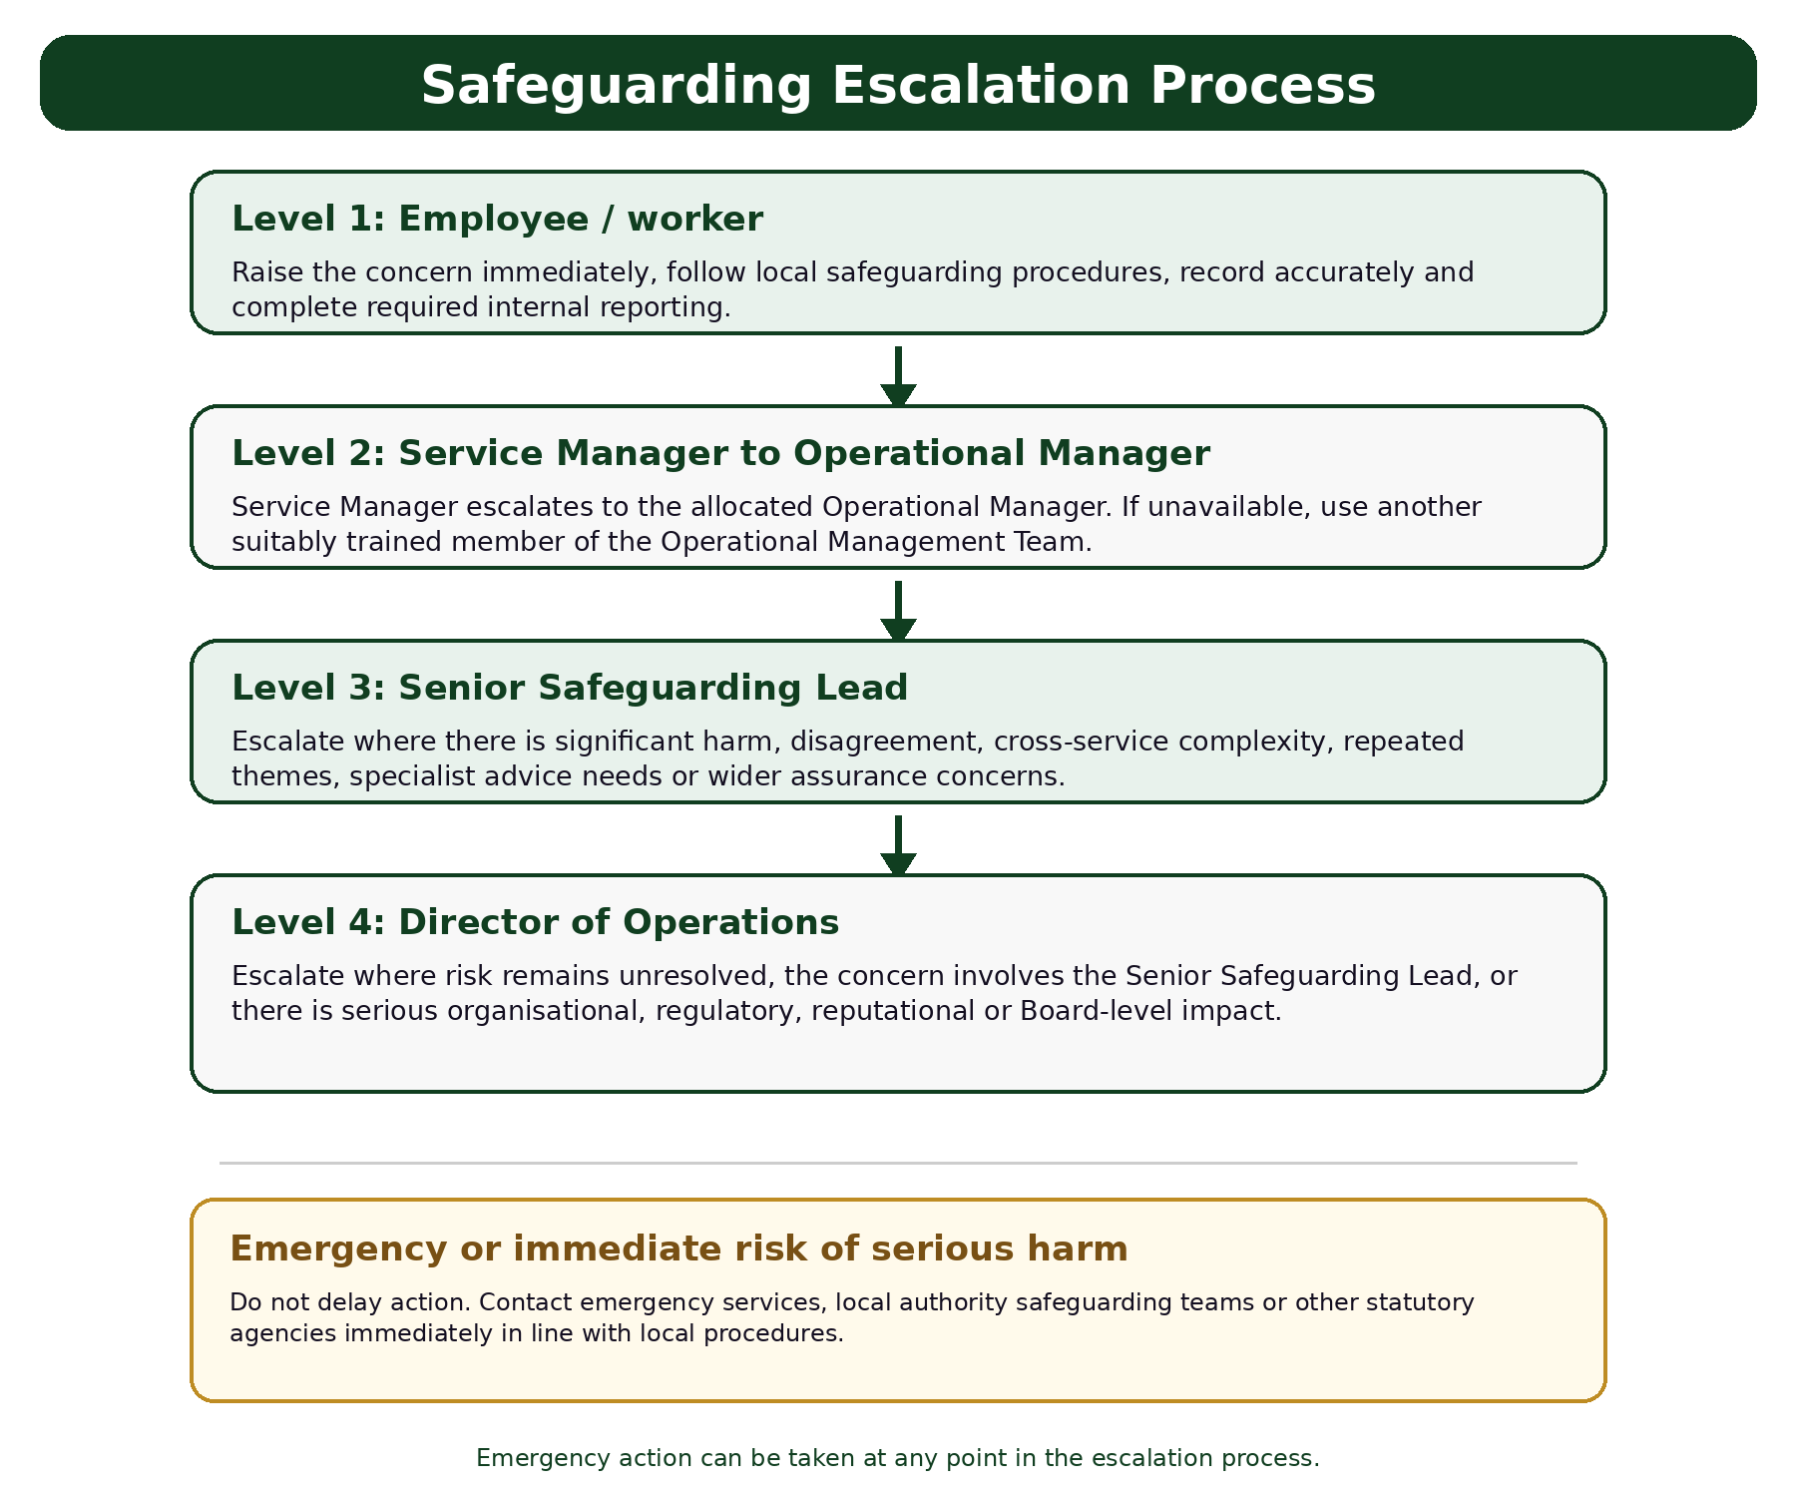

Figure: Safeguarding escalation process

- Reporting Concerns

  - Inspire North recognises that it has a duty to act on reports or suspicions of abuse and believes that the safety of the child should override any doubts, hesitations, or other considerations (such as the potential to have a negative impact on professional relationships with a family). Employees will take immediate action if there is a suspicion that a child has been abused or is likely to be abused.

  - Article 3 of the Human Rights Act effectively imposes an obligation on the authorities to take preventative measures to protect a child at risk of harm.

  - When worrying changes are observed in a child’s behaviour, physical condition or appearance or in the relationship with the parent, employees must:

    - Initially talk to a child/young person about what you are observing. It is okay to ask questions, for example: “I’ve noticed that you don’t appear yourself today, is everything okay? But never use leading questions.

    - Listen carefully to what the young person has to say and take it seriously. Act at all times towards the child as if you believe what they are saying;

    - Never investigate or take sole responsibility for a situation where a child talks about matters that may be indicative of abuse. It is not the responsibility of employees to investigate incidences of suspected child abuse but to gather information and refer only;

    - Always explain to children and young people that any information they have given will have to be shared with others, if this indicates they and or other children are at risk of harm;

    - Notify their line manager and the Designated Safeguarding Officer if abuse or potential abuse is disclosed immediately. The employee’s line manager will remain closely involved with referrals in order to support and guide the employee through the subsequent process.

    - Record what was said as soon as possible after any disclosure. If a child or young person has disclosed abuse, then the employee who they disclosed to must complete a proforma (Appendix 1).

    - Respect confidentiality and file documents securely;

    - CQC registered services must notify CQC of any child safeguarding concerns, alerts or referrals that are made by following local protocols for their service.

    - Adult Social Care (ASC) commissioned services must notify ASC of any child safeguarding concerns, alerts or referrals that are made by following local protocols for their service.

7.4 Notification of Concerns to Ofsted:

7.5 This section outlines the procedures for notifying Ofsted of significant events and incidents that occur within the setting, ensuring compliance with statutory requirements and safeguarding the welfare of all children in our care.

7.6 Responsibilities: The responsibility for notifying Ofsted lies primarily with the Ofsted Registered Manager (ORM) or the Nominated Individual (NI) in their absence. It is crucial that all employees are aware of this procedure and know who the RM and NI are. At the time of publishing the ORM Is Ben Joslin and the NI is Will Goode.

7.7 Criteria for Notification
The following events must be reported to Ofsted as soon as possible, but no later than 14 days after the occurrence:

    - Serious accidents, injuries, or illness:
  - Any injury to a child that requires medical attention.
  - Any illness that involves a child being admitted to the hospital.
  - Any death of a child.

7.7.2 Allegations of abuse:
  - Any allegations of serious harm or abuse by any person working or looking after children at the premises (whether the allegations relate to harm or abuse committed on the premises or elsewhere).
  - Any other abuse which is alleged to have taken place on the premises.

7.7.3 Significant events:
  - Any significant changes to the premises which may affect the quality of care provided.
  - Any change in the identity of the manager.
  - Any other event that may affect the suitability of the provider or any person who cares for or is in regular contact with children.

7.8 Procedure for Notification

7.8.1 Immediate Reporting:
  - As soon as the ORM/NI becomes aware of a notifiable event, they must gather all relevant information and document the incident thoroughly.
  - The ORM/NI should then make an initial report to Ofsted as quickly as possible if the incident is particularly serious and followed by a written report.

    - Written Report:
  - The written report to Ofsted should include the following details:
    - The name, date of birth, and address of the child or children involved.
    - The date and nature of the incident.
    - Actions taken in response to the incident.
    - Any measures put in place to prevent a recurrence.
    - Details of any medical treatment or advice sought.
    - Any other relevant information.
7.8.3 Documentation and Records:
  - All correspondence with Ofsted must be documented in Datix and kept securely within the safeguarding records.
  - Copies of any notifications sent to Ofsted, along with any responses received, should be recorded on Datix

- Making a Safeguarding Referral

  - If an employee has concerns for a child at risk of significant harm (see Section 4 of this Policy for definitions) then a Child Safeguarding referral must be made to children’s services under Section 47 of the Children Act 1989. This referral can be made without the parents’ consent, though parents should be informed unless it is believed that to do so would place the child at an increased risk of harm.

  - In cases where an employee believes that a child’s welfare is likely to suffer without the provision of services, then a referral can be made under Section 17 of the Children Act. This is called a ‘Child in Need’ referral. Most children with a disability are classed as Children in Need for example, and it can also be good way to get parenting help, or nursery provision to provide some respite. However, Section 17 referrals need parental consent. Ideally, the parent should make the referral themselves.

  - If consent cannot be obtained but you still have concerns then your task is to keep the parent engaged and alleviate their concerns about Social Services involvement, to try and get their consent for a S17 referral. If the situation escalates, then you will be in a position to make a S47 referral without their consent. The other option is to get more information about whether anyone has completed an Early Help Assessment or arrange for one to be completed if necessary.

  - Article 3 of the Human Rights Act effectively imposes an obligation on the authorities to take preventative measures to protect a child at risk of harm.

  - Child Safeguarding Referrals can be made via telephone, please refer to the relevant area website listed below for contact details:

COUNTY DURHAM

Darlington
https://www.darlington-safeguarding-partnership.co.uk/

Durham
https://www.durham.gov.uk/firstcontact

NORTH YORKSHIRE:
http://www.safeguardingchildren.co.uk/referral-process

Redcar
https://www.redcar-cleveland.gov.uk/children-and-families-services/concerns-about-a-child

SOUTH YORKSHIRE:

Doncaster
https://www.doncaster.gov.uk/services/schools/children-s-services-delivering-social-care-and-safeguarding-to-children-young-people-and-families

Rotherham
https://www.rscp.org.uk/

Sheffield
https://www.safeguardingsheffieldchildren.org/

WEST YORKSHIRE:

Leeds
https://www.leedsscp.org.uk/About-us

Kirklees
http://www.kirkleessafeguardingchildren.co.uk/procedures-guidance.html

Bradford
https://www.saferbradford.co.uk/children/

Wakefield
https://www.wakefieldscp.org.uk/

  - ALL PROFESSIONALS MUST CONFIRM VERBAL AND TELEPHONE REFERRALS TO LOCAL SAFEGUARDING CHILDREN BOARDS, IN WRITING, WITHIN 24 HOURS.

  - In an emergency or outside office hours contact the local Children’s Social Care Services Out of Hours Service / Emergency Duty Team, You will find the contact numbers for each area on the websites above, or contact the police on:

    - For all Police enquiries call 101 for non-urgent and 999 for emergencies.

    - North Yorkshire Police http://www.northyorkshire.police.uk/contact

    - South Yorkshire Police http://www.southyorks.police.uk/contactus

    - West Yorkshire Police http://www.westyorkshire.police.uk/contactus

  - If the child is known to have an allocated social worker, referrals should be made directly to the allocated worker or, in their absence, the manager or a duty officer in that team.

  - In the event that an agency does not agree with the response and decisions about the referral to the Children’s Social Care Services, the referring agency should discuss their concerns directly with the line manager of the social worker, in the first instance to seek resolution. See also:

    - Resolving Professional Disagreements Procedure https://westyorkscp.trixonline.co.uk/chapter/resolving-multi-agency-professional-disagreements-and-escalation West Yorkshire (Kirklees, Bradford, Wakefield etc.)

    - Concerns Resolution Process https://www.leedsscp.org.uk/practitioners/local-protocols/concerns-resolution – West Yorkshire

  - Parents / carers must be informed about any referral to Children & Young people’s Social Care unless to do so would place the child at an increased risk of harm.

- Employees must:

  - In all cases discuss their concerns or any allegations with their line manager and/or the Designated Safeguarding Officer and record and date everything;

  - Any employee who receives an allegation of abuse must make the safeguarding referral immediately by using the information detailed in Appendix 2. An inability to find all of the information detailed must not delay a referral. The Proforma for recording disclosure of abuse by a child or young person (Appendix 1) should also be completed at this stage and a copy passed to the Designated Safeguarding Officer;

  - Complete a Datix form https://inspirenorth.gateway.prod-uk.datixcloudiq.co.uk/capture/?form_id=1&module=INC and escalate to appropriate level. Ensure this has been noted on Client Case Management System Inspire Net.

  - Follow up referrals in writing within 48 hours using the format in Appendix 2, ensuring it is signed and dated. This list is an ideal, however you will not always have this level of information at the point of referral, don’t delay a referral to find out all this information.

  - A copy of all Safeguarding Children’s referrals should be sent to the Designated Safeguarding Officer;

  - Notify CQC or Adult Social Care of any safeguarding or child welfare concerns, alerts or referrals as required by legislation or contractual obligation;

  - Respect confidentiality and file documents securely;

  - Identification of the referrer is not essential for enquiries to begin but gives credibility to the source of information. Inspire North expects its employees to divulge this information where known;

  - The information should be treated in confidence by Social Services and should not be disclosed to anyone outside of the department;

  - Inspire North employees should consider informing the Police when a child is considered to be at imminent risk of serious harm. Social Care should also be contacted in such circumstances;
  - Employees can also seek advice and clarity about a situation that is of concern through the NSPCC National Child Safeguarding Helpline on 0808 800 5000 or email help@nspcc.org.uk

  - The Line Manager should always complete a Management Report Pro Forma Appendix 3 and ensure this is passed to the Responsible Director.

- Response to expect following a referral

  - Once the referral has been accepted by local authority children’s social care the lead professional role falls to a social worker.

  - The social worker should clarify with the referrer, the nature of the concerns and how and why they have arisen.

  - Within one working day of a referral being received a local authority social worker should make a decision about the type of response that is required. This will include determining whether:

    - the child requires immediate protection and urgent action is required;

    - the child is in need, and should be assessed under section 17 of the Children Act 1989;

    - there is reasonable cause to suspect that the child is suffering, or likely to suffer, significant harm, and whether enquires must be made and the child assessed under section 47 of the Children Act 1989;

    - any services that are required by the child and family and any further specialist assessments are required in order to help the local authority to decide what further action to take.

Related Policies and Procedures
This policy should be read alongside the following organisational policies and procedures:
- Adult Safeguarding Policy
- Compliments, Concerns and Complaints (Feedback) Policy
- Whistleblowing Policy
- Safer Recruitment Policy and Procedures
- Supervision Policy
- Equality, Diversity and Inclusion Policy
- Information Governance Framework
- Data Protection Policy
- Data Retention and Destruction Guidelines
- Self-Harm Policy
- Client Risk Management Policy
- CAT-SIRF (Client and Tenant Safety Incident Response Framework) including After Action Reviews
- Serious Incident Management Procedures
- Disciplinary Policy
- Performance Improvement Policy
- Lone Working Policy
Employees are expected to familiarise themselves with these policies where relevant to their role.

- Safer Recruitment

  - Sometimes there are people who work or seek to work with children and young people who may pose a risk to children and who may harm them. Ensuring that we have a clear process for recruiting employees and volunteers helps reduce this risk.

  - All candidates wishing to work for Inspire North are recruited using the same recruitment and selection process which includes the following steps:

    - Application forms are used to assess the candidate’s suitability for the role. This makes it easier to compare the experience of candidates and helps us to get all of the important information we need to ask;

    - We make clear our commitment to safeguarding and protecting children in our recruitment materials;

    - Application forms ask about any criminal convictions, cautions, other legal restrictions or pending cases that might affect a candidate’s suitability to work with children;

    - All candidates have a face-to-face interview with pre-planned and clear questions;

    - We check the candidate’s identity by asking them to bring photographic ID;

    - We check the candidate actually holds any relevant qualifications they say they have;

    - We apply for a DBS check for all employees who have contact with children or have access to our records, including volunteers and committee / board members. Where we appoint a worker from abroad DBS checks may not be able to be undertaken. Nevertheless, we will seek to obtain a “fit person” check where available from the country the person is moving from;

    - We always check all references provided;

    - New employees are provided with a copy of our safeguarding procedures.

- Management and supervision of employees

  - Inspire North is committed to the appropriate management and supervision of employees in relation to safeguarding children.

  - Employees will receive regular supervision meetings in line with the organisation supervision policy. These will be recorded and the notes agreed by both parties.

  - When an employee is involved in child safeguarding issues this will be reviewed within supervision i.e. recordings, assessments, monitoring arrangements etc and decisions relating to the level of involvement will be taken by the appropriate person within the organisation.

  - When an employee is a member of a child safeguarding core group, working with a child who is subject to a child safeguarding plan, discussion of the case will be a standing agenda item in supervision.

  - Supervisors will ensure that information about children is appropriately shared with other organisations and that they will be informed if work ceases with a child when other organisations are involved.
  - Employees will be able to access ad hoc time for support if required.

  - In exceptional circumstances external supervision may be granted at the discretion of the senior management team.

  - Peer Supervision is available in some teams.

- Managing allegations made against an employee or volunteer

  - The aim of this section of our policy is to ensure a child is protected and the employee treated fairly. Employees are entitled to receive support from an independent colleague or other professional throughout the process.

  - Any allegation of abuse of a child by an employee must be taken seriously. This includes allegations of abuse occurring within, or outside of working hours and responsibilities. It also involves allegations of domestic abuse involving an employee, where it is known that there are also children living in the household.

    - Any allegations against employees will be taken seriously.

    - The DSL will liaise with the Local Authority Designated Officer (LADO) to handle the allegation.

    - Disciplinary procedures will be followed where necessary.

    - The safeguarding process is comprehensive and involves multiple agencies to ensure the child's safety. It's crucial to act promptly and follow the appropriate channels to report concerns, ensuring the child receives the necessary protection and support.
13.3 PIPOT (People in Positions of Trust)
13.4 PIPOT is a safeguarding framework in England that addresses concerns about individuals who work with or have access to vulnerable groups, including children. The purpose of PIPOT is to ensure that any concerns about the behaviour of these individuals are appropriately managed to protect vulnerable individuals from harm.

  - Key Aspects of PIPOT Safeguarding

13.5.1 Identification of Concerns:
Concerns may arise from various sources, including allegations of inappropriate behaviour, criminal activity, breaches of professional boundaries, or any actions that suggest a person in a position of trust may pose a risk to children or vulnerable adults

    - Reporting Concerns:
  - Concerns should be reported to the designated safeguarding lead (DSL) within the organisation where the person works or volunteers.
  - The DSL or a senior manager should refer the concern to the Local Authority Designated Officer (LADO).

13.5.3 Role of the LADO:
  - The LADO is responsible for managing and overseeing individual cases
of concerns about people in positions of trust.
  - They provide advice and guidance to employers and voluntary organisations, liaise with the police and other agencies, and monitor the progress of cases to ensure they are dealt with thoroughly and fairly.

13.5.4 Initial Evaluation:
The LADO conducts an initial evaluation to assess the nature of the concern and determine the appropriate course of action. This may include:
    - Referring the matter to the police if there is a criminal element.
    - Undertaking a safeguarding risk assessment.
    - Considering whether immediate action is required to protect children or vulnerable adults.

13.5.5 Multi-Agency Strategy Meetings:
  - If the concern meets the threshold for further investigation, a strategy meeting may be convened. This involves representatives from relevant agencies, such as social services, the police, and the employer, to share information and agree on a plan of action.
  - The strategy meeting will consider whether the person poses a risk, what immediate actions are necessary (such as suspension from duties), and what further investigations are needed.

    - Investigation:
Depending on the outcome of the strategy meeting, an investigation may be conducted. This can involve:
    - Internal investigation by the employer.
    - Police investigation if a criminal offence is suspected.
    - Professional regulatory body investigation if the individual is a member of a regulated profession.
    - N.B - An internal investigation must not be carried out whilst a police investigation is taking place.

13.5.7 Outcome and Actions:
The outcome of the investigation may result in various actions, such as:
    - Disciplinary action by the employer.
    - Referral to a professional regulatory body.
    - Criminal prosecution.
    - Recommendations for training or other corrective measures.

13.5.8 Recording and Monitoring:
  - Detailed records of the concern, investigation, and outcomes should be maintained. This ensures transparency and accountability.
  - The LADO monitors the progress of cases and ensures that they are resolved in a timely and appropriate manner.
    - Support for Affected Parties:
Support should be provided for the person who raised the concern, the individual who is the subject of the concern, and any children or vulnerable adults affected by the situation.
  - PIPOT safeguarding processes are crucial for maintaining the safety and well-being of children and vulnerable adults by ensuring that concerns about individuals in positions of trust are handled appropriately and effectively. Reporting concerns promptly and following the correct procedures helps protect those at risk and maintains trust in organisations that work with vulnerable groups.

  - Inspire North will ensure that any allegations made against employees will be dealt with swiftly and in accordance with these procedures:

    - Action must be taken to ensure that the child is safe and away from the person against whom the allegation is made.

    - The Designated Safeguarding Officer must be informed immediately. In the case of an allegation involving the aforementioned, alternative arrangements should be sought to ensure that the matter is dealt with by an independent person. (Note: this could be a Director or anyone more senior within the organisation believed to be independent of the allegations being made).

    - The Designated Safeguarding Officer should contact the local authority designated officer (LADO) - who is based within Children and Young People’s Social Care Safeguarding Children Unit within 1 working day, for advice on how to proceed with the immediate situation. Contact details can be found on local authority websites (see Appendix 7). Outside of working hours the Emergency Duty Team can give advice and/or in the event of an emergency arising, the police.

    - The individual who first received/witnessed the concern should make a full written record of what was seen, heard and/or told as soon as possible after observing the incident/receiving the report. It is important that the report is an accurate description. The responsible director (if appropriate) can support the worker during this process but must not complete the report for the worker. This report must be made available on request to the police and/or Children and Young People’s Social Care.

    - Regardless of whether a police and/or Children and Young People’s Social Care investigation follows, Inspire North will ensure that an internal investigation takes place and consideration is given to the use of disciplinary procedures. This may involve an immediate suspension and/or ultimate dismissal dependant on the nature of the incident. Advice must be sought from the People Team in this instance.

- Recording and managing confidential information

  - The referral must be stored in compliance with the Inspire North Information Governance Framework including the Data Protection Policy and Data Retention and Destruction Guidelines.

  - All employees hold a duty of confidentiality to all clients who receive a service from Inspire North. This duty of confidentiality, however, is not absolute. All enquiries into the death of child find that information sharing between professionals and agencies is essential if children are to be safe.

  - The Department of Health guidance, Information Sharing and Mental Health (DH 2009) makes it clear employees have to share information between organisations and professionals to ensure that people get the services they need. Ordinarily the consent of the client should be obtained before sharing information with other organisations. However, if there are valid concerns that a child may be at risk of significant harm then confidential information regarding a client can be shared.

  - The Data Protection Act (2018), the Human Rights Act (1998) and the Freedom of Information Act (2000) all permit the disclosure of confidential information without the consent of the subject or upon the receipt of a Court Order. The protection of children overrides the duty of confidentiality.

- Management Reviews

  - Service managers will undertake management reviews of all safeguarding referrals. This will usually be done in team sessions where peer support can be accessed, and joint learning can take place. The format can be found in the proforma at Appendix 3.

  - A management review focuses on the details of a case. It allows employees to look at what they may do/feel in similar circumstances and create a venue for sharing expertise and ensures good practice. It allows for further discussion where employees remain concerned for the child and feel the response from statutory agencies has not been robust.

  - Where this is the case, the Service Manager should write to the Social Care Department expressing concerns and copy in the Designated Safeguarding Officer.

  - Any learning should be communicated to the Designated Safeguarding Officer.

- Online Safety

  - All residential supported accommodations that support children (16-18 years old) provide free internet to young people. This is the organisations ‘Guest’ corporate network, which includes the same security measures, filters and blocks that our main corporate network uses. The network is provided by our main IT supplier who also blacklist untrusted and prohibited sites, high-risk platforms, and social media. Personal devices brought to our service are also expected to follow these safety measures.

  - We encourage open communication, and employees are expected to handle reports sensitively and take immediate action to support the young person and escalate as necessary. If a young person reports accessing an inappropriate site this is to be raised as a serious concern with the system controller Razor Blue, the service manager and a Datix is to be completed. RazorBlue will then add the site to the ‘Blacklist’. The young person’s parent or guardian should be notified if appropriate. The young person’s social worker or care team should be notified if one is in place.

  - In the event a young person raises that they have experienced abuse online in any form referenced in section 4.6 then this is escalated to the service manager, the local safeguarding team and if this occurs within an Ofsted registered service this must be escalated to the Ofsted registered Manager or Nominated individual to inform Ofsted.

- Self-Harm
17.1 Self-harm or self-injury refers to the act of hurting yourself on purpose, usually to relieve feelings of distress. Methods of self-harm include cutting, burning, scratching, ligaturing or taking overdoses of medication. Other behaviours can also be indicative of self- harming intent such as taking substances, under-eating or over-exercising.
17.2 Employees should adopt an open, non-judgemental, and compassionate approach to working with young people who self-harm. This allows for a trusting and supportive relationship to be built which is the primary driver and mechanism for supporting behavioural change. Open, regular discussion about self-harm supports better safety planning and reduces the likelihood that the client will feel shame which can lead to understating the impact or risk of their actions.
17.3 Employee’s should support the young person to access suitable professional
support to help keep the young person safe and to help the young person to better
understand their previous experiences and behaviours of self-harm (where applicable). Employees should keep appropriate records of self-harming incidents and share relevant information and decisions with the young person’s accommodating authority and other relevant professionals. The young person should be involved in decision making around any changes to their support package and living arrangements. For Further information please see the Inspire North Self Harm Policy located on INsite.

- Suicide Prevention
18.1 Risk Assessment and Safety Plans: Each young person must have a current and detailed risk assessment upon entry to identify any known vulnerabilities, including risks of self-harm or suicidal ideation. Personalised safety plans are developed in collaboration with young people and their care team to provide appropriate interventions and promote safety.
18.2 Employee Training and Awareness: All clinical employees receive safeguarding, risk assessment and trauma informed training to recognise signs of mental health distress, including indicators of suicidal ideation. Employees are equipped to respond sensitively and effectively, prioritising empathy, confidentiality, and prompt intervention.
18.3 24/7 Access to Support: All Children within residential services have access to on-call support from trained Employees, ensuring immediate help is available if a young person is in crisis. This support includes emergency protocols for accessing external mental health services when necessary.
18.4 Creating a Supportive Environment: Our accommodation promotes an open, supportive environment where young people feel safe discussing their emotions and mental health concerns without fear of judgment. Regular check-ins provide additional opportunities to monitor well-being.
18.5 Collaboration with Mental Health Services: Employees are required to maintain close partnerships with local mental health agencies, social services, and crisis teams to ensure a coordinated response when a young person is struggling. Where necessary, we will support young people in accessing counselling, therapy, or crisis intervention services.
18.6 Safety Planning and Family/Carer Involvement: For young people identified as at risk, we work collaboratively to review and adapt their personalised safety plan, which may involve notifying and engaging with parents, carers, guardians, social care and mental health professionals when it is deemed in the best interest of the young person and complies with safeguarding guidelines.
18.7 Injury or Death: In the event a young person causes serious harm to themselves or dies by suicide this is a serious incident. In this event inform the service manager, operational manager and director of operations. A Datix and serious incident form will need to be completed as quickly as possible and no later than 72 hours after the event. The commissioning organisation will need to be notified. If the young person is supported by a service supported by CQC or Ofsted then they will need to be notified as soon as possible and no later than 14 days after the incident has occurred. For an Ofsted registered service, the Ofsted Registered Manager and nominated individual need to be informed.
18.8 For more information in relation to suicide please see the Inspire North’s Policies (Self harm, Client Risk and Management of Serious Incidents) available on insight.
- Policy Review

  - This policy will be disseminated through the Inspire North Leadership Forum and then to all teams.
This policy will be formally reviewed at least every three years.
An earlier review will take place where:
Relevant legislation changes.
Statutory safeguarding guidance changes.
Learning is identified through safeguarding incidents, serious incidents, reviews, domestic homicide reviews, child safeguarding practice reviews, complaints or audits.
Changes occur to organisational structures or safeguarding responsibilities.
Significant concerns are identified regarding the effectiveness of this policy.
In addition to formal review periods, the effectiveness of this policy will be monitored through safeguarding governance processes, audits, training compliance monitoring and the review of safeguarding incidents.
This will happen via our quarterly Clinical Governance meetings as well as the annual Board Member Safeguarding Report.
An annual review of the effectiveness of this policy will be undertaken with employees via the relevant organisational governance route, such as Inspire North's Domestic Abuse and Safeguarding Forum, Clinical Governance meetings or other relevant safeguarding governance forum.

20 General

20.1 As part of Equality and Diversity, this policy has undergone an Equality and Diversity Impact Assessment Screening. This is attached at the end of this policy as an appendix.

Appendix 1

Proforma for recording disclosure of abuse by a child or young person
Date of disclosure: |  |  | Time of disclosure:
Name of child/young person:
What they disclosed:
Internal Actions:  Is the child/young person safe?  ☐ Yes ☐ No |  | External Actions:  Has a safeguarding referral been made?  ☐ Yes ☐ No |  | Employees Name:
 |  |  |  | Signature:
Has the Responsible Director been  informed?  ☐ Yes ☐ No |  |  |  | Line Managers Name:
 |  |  |  | Signature:

Appendix 2
Referral Information Required

The person making the referral should provide the following information if available - note - absence of information must not delay a referral:

- Full name, any aliases, date of birth and gender of child/children;
- Full family address and any known previous addresses;
- Identity of those with parental responsibility;
- Names, date of birth and information about all household members, including any other children in the family, and significant people who live outside the child’s household;
- Ethnicity, first language and religion of children and parents/carers;
- Any need for an interpreter, signer or other communication aid;
- Any special needs of the children;
- Is the child registered at a school or regularly attending a school? If so, identify the school;
- Any significant/important recent or historical events/incidents in the child or family’s life;
- Has the child recently spent time abroad or recently arrived in the area?
- Cause for concern including details of any allegations, their sources, timing and location;
- The identity and current whereabouts of the suspected/alleged perpetrator;
- The child’s current location and emotional and physical condition;
- Whether the child is currently safe or is in need of immediate protection because of any approaching deadlines (e.g. child about to be collected by alleged abuser);
- The child’s account and the parents’ response to the concerns if known;
- The referrer’s relationship and knowledge of the child and parents/carers;
- Known current or previous involvement of other agencies/professionals;
- Information regarding parental knowledge of, and agreement to, the referral.

Appendix 3
Management report pro forma

Service: | Child’s Name:
What was our involvement with this child and family?
Discussion and analysis of involvement.
Outcomes and response from Social Care / the Police
What did we learn from this case?
Recommendations for action
Report sent to responsible director (please tick): YES NO
Signed: Date:
Print Name:

West Yorkshire Police Headquarters  PO Box 9  Wakefield  WF1 3QP | Phone 01924 293956  Fax: 01924 293999  cib@westyorkshire.pnn.police.uk | 

Appendix 4

Female Genital Mutilation - Mandatory Reporting to Police

Pro-Forma for Use by Health, Teaching and Social Care Professionals.

(Compliance with Section 5B of the Female Genital Mutilation Act 2003, as inserted by Section 74 of the Serious Crime Act 2015).

This pro-forma should be used by regulated professionals to comply with the requirements of the above legislation in order to report to West Yorkshire Police details of children who they discover to have been subject to female genital mutilation.

When completed it should be e mailed to: cib@westyorkshire.pnn.police.uk

Referring professionals will receive a return e mail quoting the police incident and crime report reference numbers.

*For internal use only: Storm no. Niche no
Female Genital Mutilation – Mandatory Reporting to Police Form
West Yorkshire Police – Version 2 – April 2016

Section 1 – About You
Referrer’s Name
Organisation
Address
Postcode
Contact Telephone Number
E-mail Address
Role
Preferred Means of contact
Section 2 – About the Child and family
Name of Child
Date of birth
Gender
Address
Postcode
School (if applicable/ known)
GP and surgery (if known)
Occupation (if applicable)
Parent/ Carer details
Address if different to child’s
Contact Telephone Number/s
E-mail Address
Ethnic Origin
Nationality
Details of other children in the family (name/ Dob/ addresses if different to above)
Parent/ carer preferred means of contact.
Please tell us if the child or the parent/ carers need an interpreter or other support when we contact them (and if so what language/ type of assistance)
Section 3 – FGM Report
Where did it occur?
When did it occur?
Please provide circumstances regarding the discovery
Please provide details of any action already taken and which other services or agencies are currently engaged with the child (e.g. social services). Please include names / contact details of any key workers if known.

Please submit your completed form to cib@westyorkshire.pnn.police.uk
Female Genital Mutilation – Mandatory Reporting to Police Form
West Yorkshire Police – Version 2 – April 2016

Appendix 5: Please Note - Policy and Procedure Snapshots are intended to give you all the essential information found within a policy, in one easily detestable chunk. They are not designed to replace the policy thus; all employees should ensure they are familiar with the full policy.

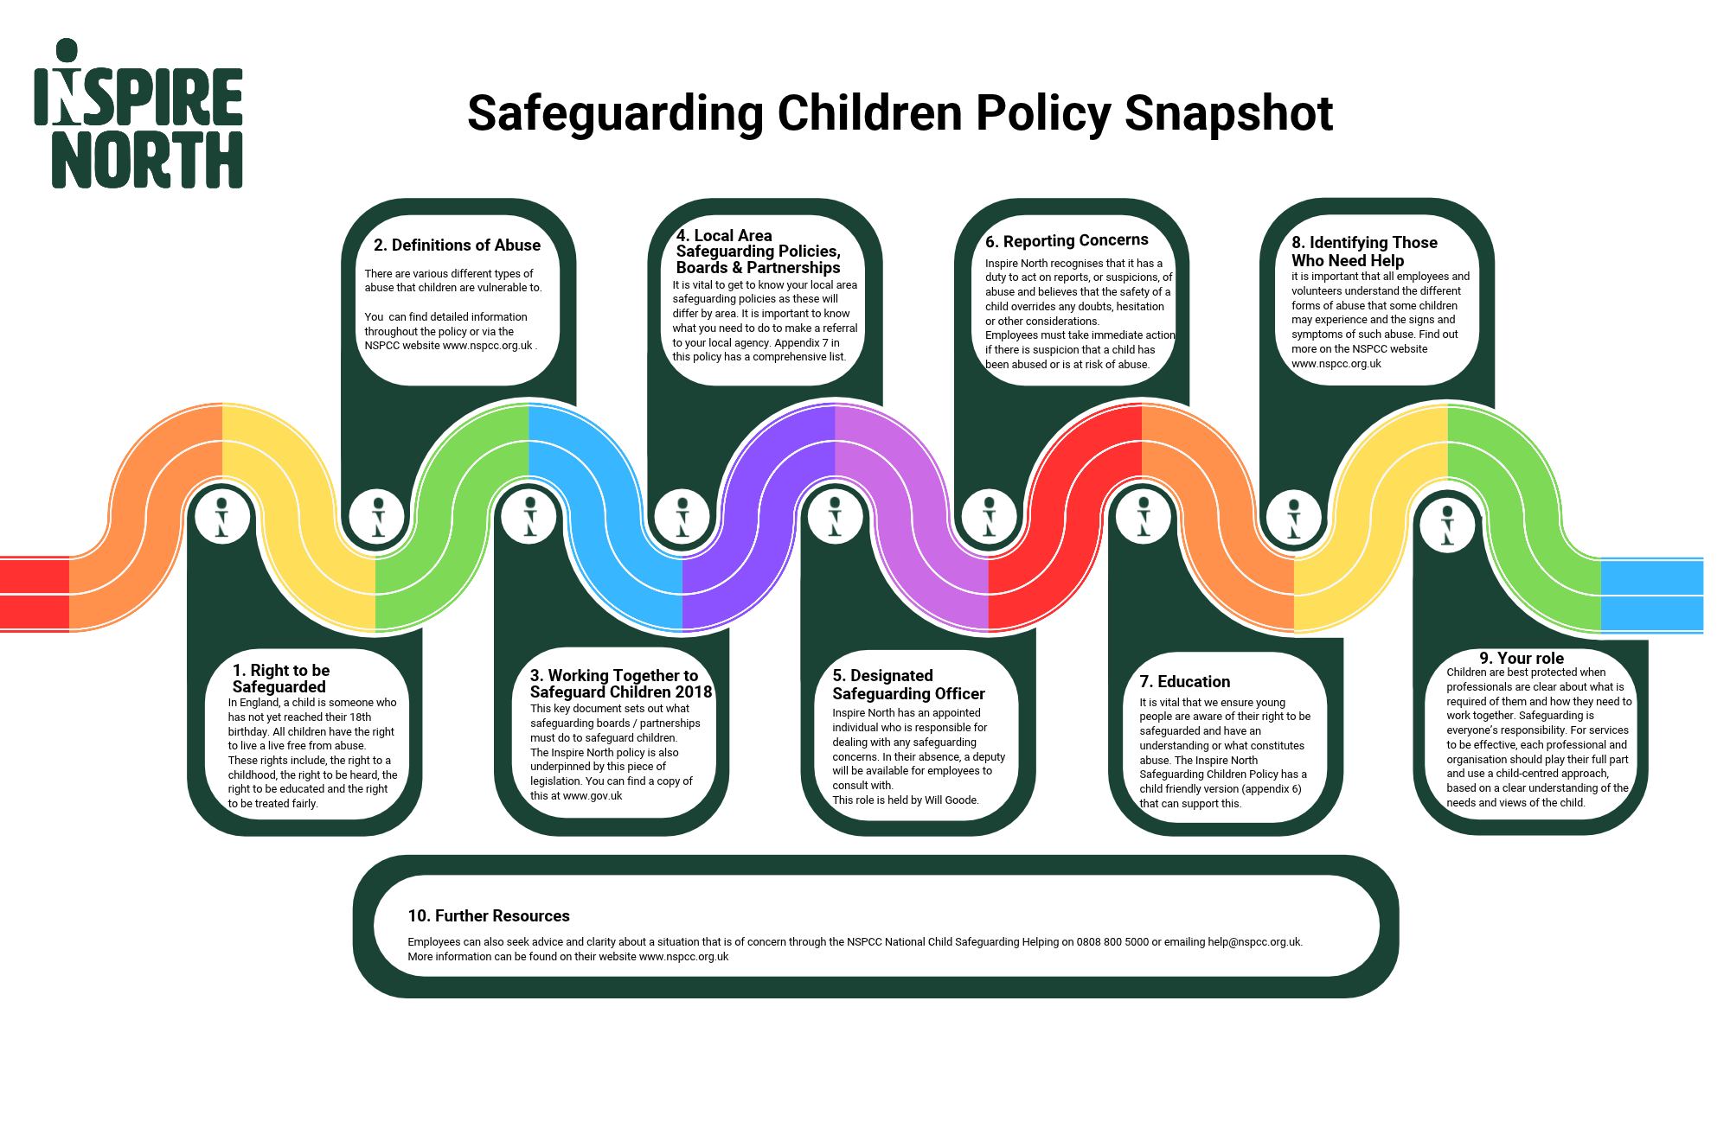

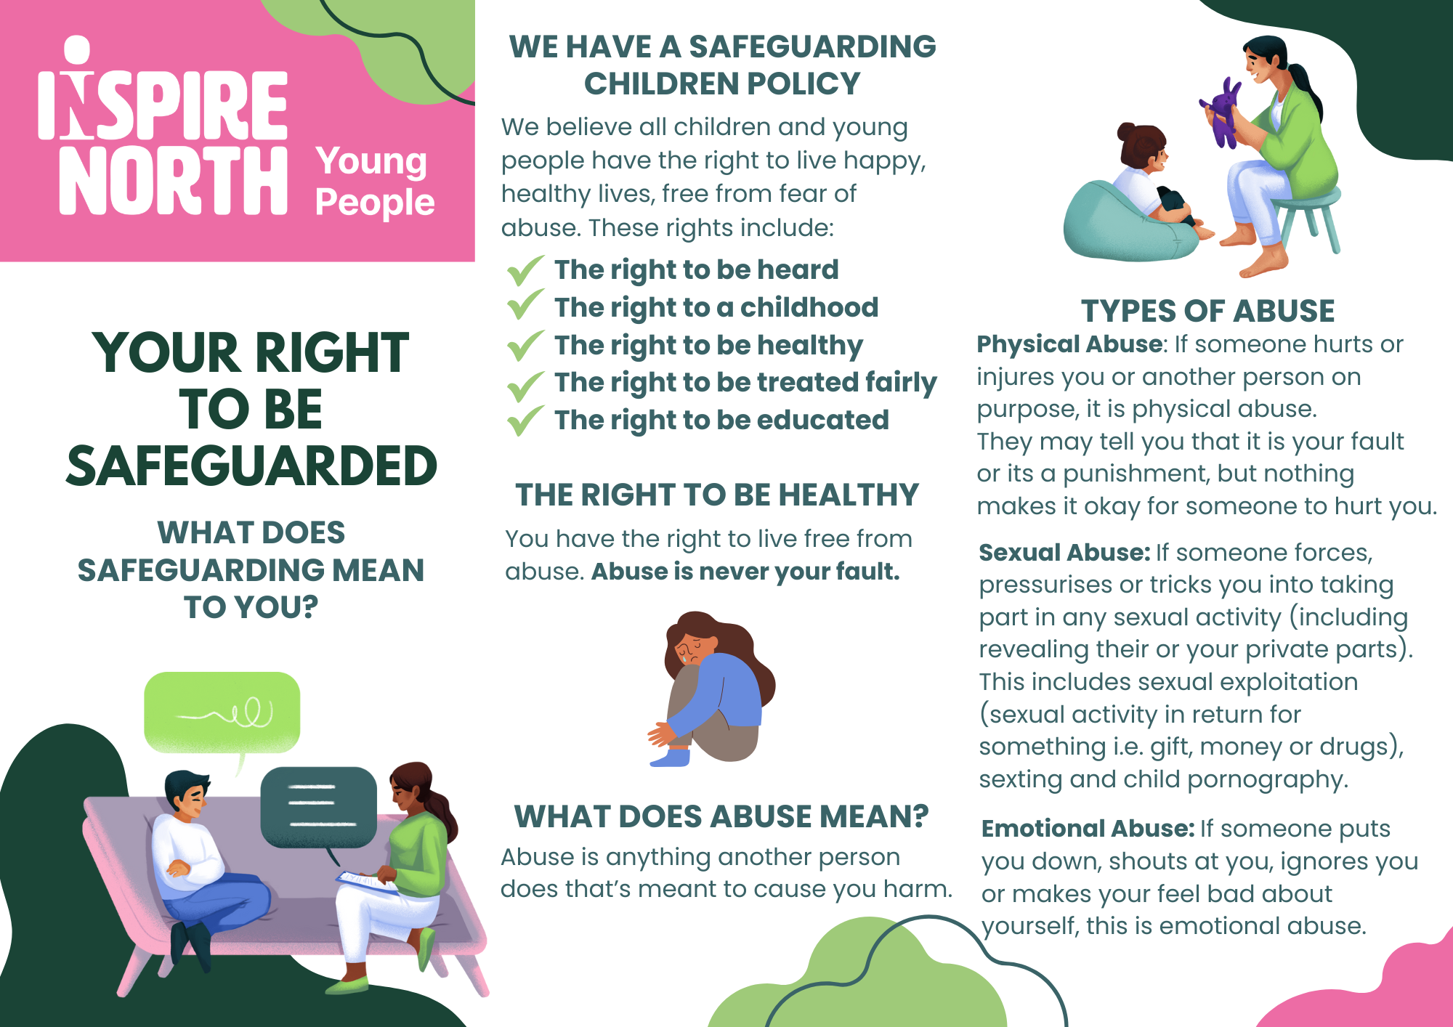

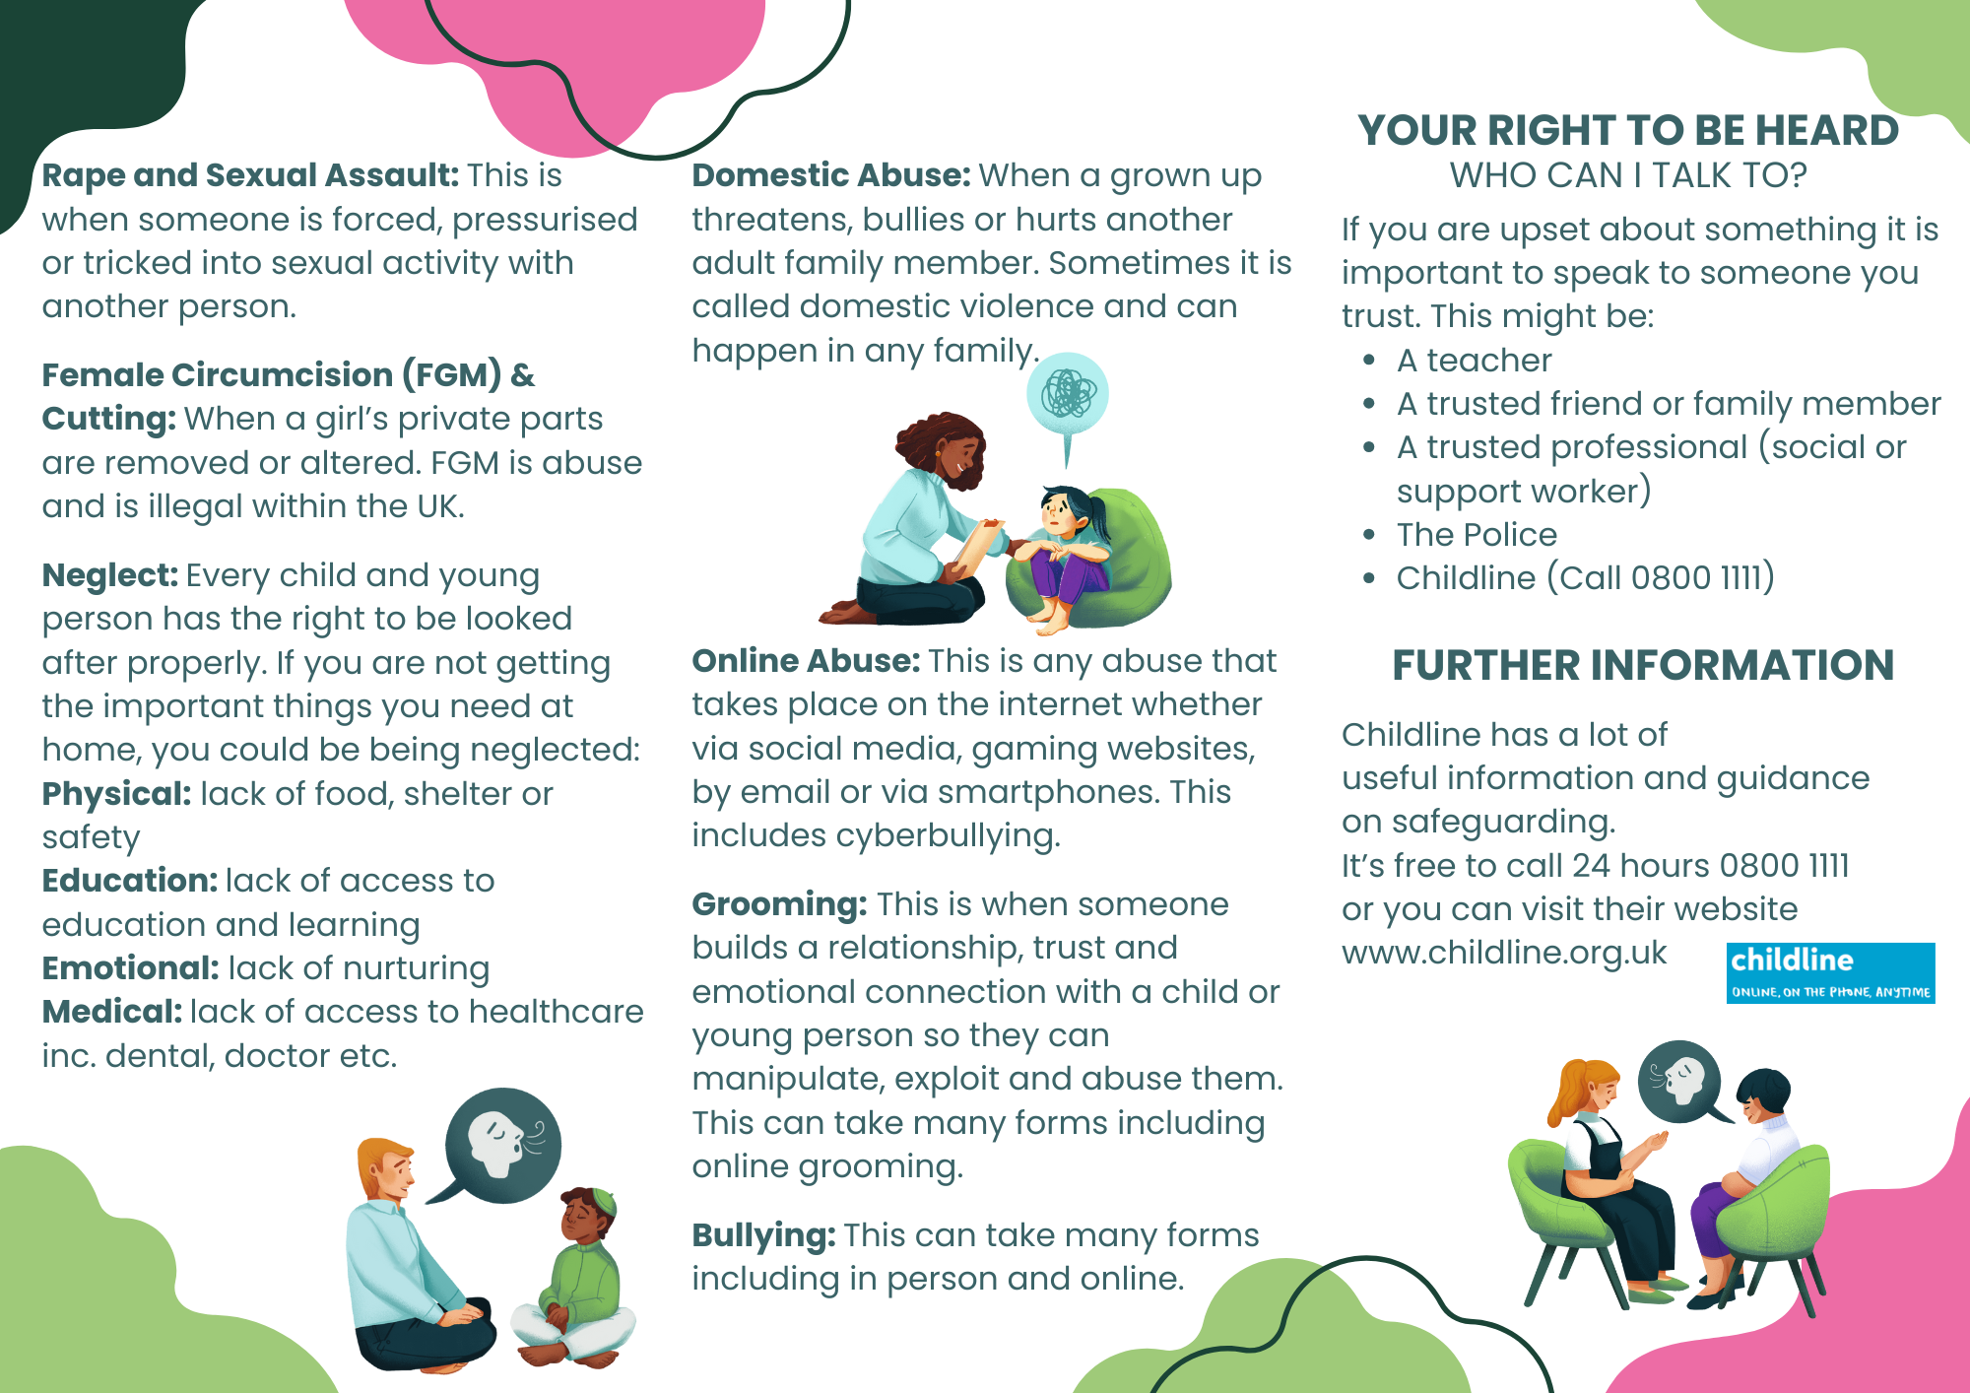

s Equality Impact Assessment

As an organisation we need to ensure that all our strategies, policies, services and functions, both current and proposed have given proper consideration to equality and diversity. This links directly to our becoming anti-racist aspiration for our organisation.

It will be an exercise that determines relevance for all new and revised strategies, policies, services and functions. This screening process will provide a record of both the process and decision making.

It needs to be completed at the earliest opportunity and it will help to determine:
- the relevance of proposals and decisions to equality and diversity.
- whether or not equality and diversity are being or have already been considered.

Organisation: | Inspire North | Service: | Operations Team (CST)
Person undertaking the screening: | Will Goode | Email: | Will.goode@inspirenorth.co.uk

- Title of what is being screened?
Strategy / Policy  ☒ |  |  | Service / Function  ☐ |  |  |  | Development  ☐
Other  ☐ |  |  | If other, please specify:
- Please provide a brief description of what you are screening?
Safeguarding Children – policy and procedures

- Relevance to equality and diversity

All of our developments, strategies, policies, and services affect clients, employees or the wider community or local communities. These will also have a greater or lesser relevance to equality and diversity.

The following questions will help you to identify how relevant your proposals are.

When considering these questions think about age, carers, disability, gender reassignment, ethnicity, religion or belief, gender and sexual orientation and also those areas that impact on or relate to equality.
Questions |  |  |  |  |  |  | Yes |  | No
Is there an existing or likely differential impact for the different equality characteristics? |  |  |  |  |  |  | ☐ |  | ☒
Have there been or likely to be any concerns about the project, policy or proposal? |  |  |  |  |  |  | ☐ |  | ☒
Could the proposal being screened affect how our services are provided and located? |  |  |  |  |  |  | ☐ |  | ☒
Could it impact on our strategies, policies and functions? |  |  |  |  |  |  | ☐ |  | ☒
Could the proposal affect our workforce or employment practices? |  |  |  |  |  |  | ☐ |  | ☒
Does the proposal involve or will it have an impact on;  - Eliminating unlawful discrimination, victimisation and harassment  - Advancing equality of opportunity  - Fostering good relations. |  |  |  |  |  |  | ☒ |  | ☐
If you have answered yes to any of the above and;
- Believe you have already considered the impact on equality, diversity, cohesion and integration within your proposal please go to section 4.
- Are not already considering the impact on equality, diversity, cohesion and integration within your proposal please go to section 5.

If you have answered no to the questions above, please complete sections 6 and 7
- Considering the impact of Equality and Diversity

- How have you considered equality and diversity?
I have considered all groups of people with various backgrounds and identities and how they can be impacted by safeguarding.
Specific information has been provided for female genital mutilation, child trafficking,
modern slavery and child sexual exploitation
Also added is the adultification of black, Asian and minority ethnic groups of children

- Key findings
The policy outlines the types of support and referral thresholds to statutory specialist and early intervention as well as key legislation to protect the rights of all vulnerable children and young adults

- Actions
This policy incorporates a diverse range of people from various backgrounds and characteristics. Any feedback during the dissemination period will be acknowledged and reviewed if any gaps or negative impact is identified.

5. If you have not already considered the impact on equality, diversity, cohesion and integration, you will need to carry out an impact assessment.
Date you will scope and plan you impact assessment: |  |  |  |  | Date you will complete the impact assessment:
Name and Job Title of person who will lead on the impact assessment:
6. Governance and approval
Please state here who has approved the actions and outcomes of the screening
Name: | Kira Moxon-Lumb |  |  | Job Title: |  | Director of Operations
Date Screening Completed: |  |  |  | Date Screening Approved:
7. Publishing Checklist
Please tick to confirm the following actions have taken place:
A copy of this screening form has been attached as an appendix to whatever it is that has been screened |  |  |  |  |  |  |  |  | ☒

