


Policies

Safeguarding adults Policy

Current Version: | 1.1 | Date of Update: | August 2026
Updated by: | Will Goode (Director of Operations)
SLT Policy Owner: | Will Goode | Policy Group: | Operations
Last Full Review: | January 2026 | Next Review Due: | February 2027
Policy Implemented: |  | 31st March 2025
Replaces previous policies: |  | n/a
If you have any queries in relation to this policy, please speak to your line manager.

Please Note: This is a controlled document. Always use the current version on INsite. Do not save or print copies, as they may be outdated.

Safeguarding adults policy

- Overview

  - Inspire North is fully committed to safeguarding and promoting the welfare of all adults. It recognises its responsibility to take all reasonable steps to promote safe practice and to protect adults from harm, abuse and exploitation. Inspire North acknowledges its duty to respond appropriately to any allegations, reports or suspicions of abuse.

  - Adults are best protected when professionals are clear about what is required of them individually, and how they need to work together.

  - Inspire North requires all its employees to work together to develop an ethos which embraces difference and diversity, and respects the rights of adults.

  - In implementing this policy Inspire North will:

    - Ensure that all employees understand their legal and moral responsibility to work to safeguard and promote the welfare of adults;

    - Ensure that all employees understand their responsibility to work to the processes that are always detailed in the organisation’s Safeguarding Adults Procedures and work towards maintaining high standards of practice;

    - Ensure that all employees are aware of local safeguarding adults board interagency procedures and are confident that they are working within these guidelines. The local boards contact details are listed in the Inspire North’s Safeguarding Adults Procedures and also displayed in services using a safeguarding notice board.

    - Ensure that all employees understand their duty to report any concerns they have about adults, or a worker’s conduct towards an adult, to their line manager and in turn to the organisation “named person” for adult safeguarding.

    - Ensure that the Designated Safeguarding Officer understands their responsibility to ensure any safeguarding adults welfare concerns are referred to the statutory adults safeguarding agencies (i.e. Police and/or Adult Social Care);

    - Ensure that such concerns, alerts or referrals are reported to Care

    - Quality Commission (CQC) and/or Adult Social Care (ASC) as required by legislation or contractual obligation.
    - Provide opportunities for all employees to develop their skills and knowledge in relation to the welfare and safeguarding of adults;

    - Ensure that adults are enabled to express their ideas and views on a wide range of issues and will have access to the organisation Feedback Policy including complaints and satisfaction;

    - Ensure that parents/carers are encouraged to be involved in the work of the organisation and, when requested, have access to all guidelines and procedures;

    - Endeavour to keep up-to-date with national developments relating to the welfare and safeguarding of adults;

    - Ensure that Inspire North’s Board are aware that they are ultimately accountable for all that happens within the organisation and are knowledgeable around the needs of the adults utilising our services.

- Introduction

  - For the purposes of this policy, a vulnerable adult is defined as anyone over the age of 18 years who:
    - has needs for care and support (whether these needs are being met or not);
    - is experiencing, or at risk of, abuse or neglect and;
    - as a result of these needs is unable to protect themselves from either the risk of, or the experience of abuse or neglect.

  - The Safeguarding Adults Procedures have been designed to safeguard and promote the welfare of any adult who is known to all services within Inspire North. They recognise that adult safeguarding can be an emotive subject and understand that some employees may find it a challenging area. However, it is important that employees respond appropriately and are aware of their responsibilities.

  - Inspire North is committed to the belief that safeguarding and promoting the welfare of adults is everybody’s responsibility and that this policy will enable all employees and volunteers to act appropriately to any concerns that arise in respect of adults.

  - Inspire North is committed to the fair treatment of its employees, potential employees or clients of its services, regardless of race, gender, religion, sexuality, responsibilities for dependents, age, physical/mental disability or offending background that does not create a risk to adults and/or would be detrimental to the organisation.

- Key principles and values of Safeguarding

  - Safeguarding is everyone’s responsibility.
  - We use a person-centred approach: for services to be effective they should be based on a clear understanding of the needs and views of adults.

  - Ensure the adults we support understand their right to be safeguarded.

  - People are supported and encouraged to make their own decisions and informed consent.

  - It is better to take preventative action before harm occurs.

  - The approach should be proportional with the least intrusive response appropriate to the risk presented.

  - We provide protection, support and representation for those in greatest need.

  - Local partnership solutions through services working with their communities in preventing, detecting and reporting neglect and abuse. Working together with Safeguarding teams, professionals, colleagues and partner agencies to prevent and respond effectively to incidents or concerns of abuse.

  - Accountability and transparency in safeguarding practice.

- Definitions

  - Abuse: A form of maltreatment of adults. Somebody may abuse or neglect an adult by inflicting harm, or by failing to act to prevent harm. Adults may be abused in a family, in an institution or community setting by those known to them or by others (e.g. via the internet). They may be abused by a partner or other relative, a friend, career, ‘trusted adult’ (e.g. professional worker) neighbours or strangers.

  - Physical Abuse: A form of abuse which may involve hitting, shaking, throwing, poisoning, burning or scalding, drowning, suffocating or otherwise causing physical harm to an adult. Physical harm may also be caused when a parent or carer fabricates the symptoms of, or deliberately induces, illness.

  - Emotional Abuse: Is the persistent emotional maltreatment of an adult such as to cause severe and persistent adverse effects on their emotional wellbeing. It may involve conveying that they are worthless or unloved, inadequate, or valued only in so far as they meet the needs of another person. It may involve preventing the person making choices, undermining their self-esteem, coercion, humiliation, blaming or controlling, causing them to feel frightened or in danger.

  - Sexual Abuse: Involves forcing or enticing a person to take part in sexual activities, not necessarily involving a high level of violence, whether or not they are aware of what is happening. The activities may involve physical contact, including assault by penetration (for example, rape or oral sex) or non-penetrative acts such as masturbation, kissing, rubbing and touching outside of clothing. It may include non-contact activities, such as involving adults in looking at, or in the production of, sexual online images, watching sexual activities.
  - Domestic abuse: Domestic abuse is any type of controlling, bullying, threatening or violent behavior between people in a relationship. It isn’t just physical violence – it includes emotional, physical, sexual, financial or psychological abuse.

  - Online Abuse: Online abuse is any type of abuse that happens on the web, whether through social networks, playing online games or using mobile phones. Vulnerable adults may experience cyberbullying, grooming, sexual abuse, sexual exploitation or emotional abuse.

  - Neglect: Is the persistent failure to meet an adults basic physical and/or psychological needs, likely to result in the serious impairment of their health and wellbeing. Neglect may involve failing to:
    - provide adequate food, clothing and shelter;
    - protection from physical and emotional harm or danger;
    - ensure access to appropriate medical care or treatment;
    - respond to a person’s basic emotional needs.

  - Self-Neglect: including neglecting personal hygiene, health or surroundings and includes behaviors such as hoarding. Self-neglect can be a common issue facing the various client groups across Inspire North, but very difficult to support clients to make informed decisions to minimise any risk to themselves. These difficulties are recognised nationally, and new research has been published to help guide local authorities in this area. Information around that can be found in the below link, with the new research highlighting the need for employees/services to:
    - Take the time to build rapport and a relationship of trust through persistence, patience and continuity of involvement
    - Seek to ‘find’ the whole person and to understand the meaning of their self-neglect in the context of their life history, rather than just the particular need that might fit into an organisation’s specific role
    - Work at the individual’s pace, spot moments of motivation that could facilitate change, even when the steps towards it are small
    - Ensure you understand the nature of the individual’s mental capacity in respect of each specific self-care decision. (see Housing Management Policy Manual: Section 5 Vulnerable Clients);
    - Be honest, open and transparent about risks and options
    - Understand and consider the legal mandates providing options for intervention
    - Be creative with flexible interventions, including family members and community resources where appropriate
    - Engage in effective multi-agency working to ensure inter-disciplinary and specialist perspectives, and coordination of work towards shared goals.
    - A link to the Leeds Safeguarding Adults Board Self Neglect Policy, which has helpful information around the national learning and research, can be found here: https://www.leedssab.org.uk/index.php/i-work-with-adults/working-support-people-who-self-neglect

  - Financial or Material Abuse: This involves having money or other property stolen, being defrauded, being under pressure in relation to money or other property, and having money or property misused.

  - Discriminatory Abuse: Discrimination on grounds of race, gender and gender identity, disability, sexual orientation, religion, and other forms of harassment, slurs or similar treatment.

  - Organisational Abuse: This includes neglect and poor practice within an institution or care setting e.g. hospital, care home or care provided in one’s own home. This may range from one off incidents to ongoing ill treatment. It can be through neglect or poor professional practice as a result of the structure, policies, processes and practices within an organisation

  - Female Genital Mutilation (FGM): FGM refers to procedures that intentionally alter, mutilate or cause injury to the female genital organs for non-medical reasons.

    - FGM is illegal in the UK. It is an offence to arrange for children to be taken abroad for FGM, and for UK nationals or permanent UK residents to abet, counsel, procure or undertake FGM abroad, even in countries where the practice is legal.

    - The Serious Crime Act 2015 (guide) extends this protection to girls under the age of 18 who are ‘habitually resident’ (or on short temporary stays) such as students and refugees. The Serious Crime Act also creates a new offence of failing to protect a girl from FGM. If an offence of FGM is committed against a girl under the age of 16, each person who is responsible for the girl at the time the FGM occurred will be liable. A ‘responsible’ person will have parental responsibility with the girl and frequent contact. Regulated professionals in health and social care professionals and teachers in England and Wales have a duty to report 'known' cases of FGM in under 18s which they identify in the course of their professional work to the police.

  - Modern Slavery and Trafficking: Adults are recruited, moved or transported and then exploited, forced to work or sold. Specified public authorities have a duty to inform the Home Office where slavery or trafficking is suspected, and voluntary agencies are encouraged to do likewise. Adults are trafficked for:
    - sexual exploitation;
    - forced marriage;
    - domestic servitude such as cleaning, child care, cooking;
    - forced labour in factories or agriculture;
    - criminal activity such as pickpocketing, begging, transporting drugs, working on cannabis farms, selling pirated DVDs and bag theft.

  - Hate crime: Any crime where the perpetrator’s prejudice against any identifiable group of people is a factor in determining who is victimised. Hate crime is a form of discriminatory abuse. Hate crimes happen because of hostility, prejudice or hatred of people due to: disability gender identity, race, ethnicity or nationality, religion or belief, sexual orientation. The definition is based on the perception of the victim or anyone else, and is not reliant on evidence.

  - Mate Crime: There is no statutory definition in UK law, but it is generally understood to refer to the befriending of people, who are perceived by perpetrators to be vulnerable, for the purposes of taking advantage of, exploiting and/or abusing them. This can strongly be associated, but not exclusively associated, with people with a learning disability or mental health problems. The perpetrator is likely to be perceived as a close friend, a carer or a family member exploiting someone who may be unaware of any hidden motives. The relationship may lead to a pattern of repeat and worsening abuse.

  - Complex (organised or multiple abuse). Defined as abuse involving one or more abusers and a number of related or non-related victims. The abusers concerned may be acting together to abuse, sometimes acting in isolation or using an institutional framework or position of authority to recruit victims for abuse. This includes neglect and poor care practice within specific care settings, and may range from isolated incidents to continuing ill treatment.

- Safeguarding

  - Safeguarding: Safeguarding means protecting an adult’s right to live in safety, free from abuse and neglect. It is about people and the organisation working together to prevent and stop both the risks and experience of abuse or neglect, while at the same time making sure that the adult’s wellbeing is promoted including and having regard to their views, wishes, feelings and beliefs in deciding on any action. This must recognise that adults sometimes have complex interpersonal relationships and may be ambivalent, unclear or unrealistic about their personal circumstance.’ (Care Act 2014)

  - Harm: Harm is defined in No Secrets (2000) as not only ill-treatment (including sexual abuse and forms of ill treatment which are not physical) but also the impairment of, or an avoidable deterioration in, physical or mental health; and the impairment of physical, intellectual, emotional, social or behavioural development.”

- Recognising Abuse

  - Whilst allegations of abuse may be raised directly by the victim through them disclosing abuse to an employee, there may be occasions where the victim is unwilling or unable to disclose. All employees must be aware and mindful of possible indicators of abuse, such as:
    - unexplained changes in mood or behavior;
    - nervousness or watchfulness;
    - inappropriate relationships with peers;
    - behavior that demands attention;
    - changes in appearance or hygiene;
    - scavenging or compulsive stealing;
    - persistent fatigue;
    - injuries inconsistent with an explanation given.

7.0 Information Sharing

7.1 Managers will need to make decisions about sharing information with external agencies, including the police and local authority. In some cases, individuals may not give their consent to the sharing of safeguarding information for a number of reasons. For example, they may be frightened, they may fear losing control, they may not trust social services or other partners or they may fear that their relationship with the abuser will be damaged. Reassurance and appropriate support along with gentle persuasion may help to change their view on whether it is best to share information.

7.2 If a person refuses intervention to support them with a safeguarding concern, or requests that information about them is not shared with other safeguarding partners, their wishes should be respected. However, there are a number of circumstances where the practitioner can reasonably override such a decision, including:
    - the person lacks the mental capacity to make that decision – this must be properly explored and recorded in line with the Mental Capacity Act
    - other people are, or may be, at risk, including children
    - sharing the information could prevent a crime
    - the alleged abuser has care and support needs and may also be at risk
    - where a serious crime has been committed
    - employees are implicated
    - the person has the mental capacity to make that decision but they may be under duress or being coerced
    - the risk is unreasonably high and meets the criteria for a safeguarding referral for example, multi-agency risk assessment conference referral or in cases of extreme self-harm or self-neglect, a referral to the local adults safeguarding board.
    - a court order or other legal authority has requested the information.
7.2 If you are in doubt about any of the above or believe there is some other reason to share information without or against the client’s consent, please speak to the Safeguarding Lead in your service or your line manager.

- Prevent Agenda

  - The Government’s counter-terrorism strategy as defined in the Counter Terrorism and Security Bill 2015 known as CONTEST. Inspire North recognises its duty to act on reports, or suspicions of radicalisation or extremism.

  - Prevent is an element of this strategy. Prevent focuses on working with vulnerable individuals who may be at risk of being exploited by radicalisers and subsequently drawn into terrorist-related activity. Violent extremists may target vulnerable people and use charisma and persuasive rationale to attract people to their cause.

  - Prevent strategy has three specific strategic objectives:
    - Responds to ideological challenge faced from terrorism and aspects of extremism and the treatment faced from those who promote these views;
    - Provides practical help to prevent people from being drawn into terrorism and ensure they are given appropriate advice and support;
    - Works with a wide range of sectors (including education, criminal justice, faith, charities, online and health) where there are risks of radicalisation that need to be addressed.

  - Channel is a key element of the Prevent strategy. It is a multi-agency approach to protect people at risk from radicalisation. Channel uses existing collaboration between local authorities, statutory partners (such as the education and health sectors, social services, children’s youth services, offender management and the police) and the local community to identify individuals at risk of being drawn into terrorism. Channel will assess the nature and extent of that risk and to develop the most appropriate support plan for the individual’s concerned.

- Responsibility of Inspire North

  - Inspire North has a responsibility to ensure that all employees are aware of this guidance, the relevant procedures to be followed and to review and update them as required. (Prevent, Respond and Learn)

  - Inspire North will ensure that:
    - Recruitment and selection procedures minimise the potential risk to clients from abusive employees including DBS checks every 3 years for all employees and a minimum of 2 professional references;
    - All employees are supervised, trained (every 3 years) and able to provide services within good practice guidelines, such as the national care standards and Supporting People Quality Assessment Framework, integrating safeguarding into management practice;
    - All employees have training to prevent, recognise, respond and report abuse, neglect, and vulnerability to extremism and radicalisation;
    - The safeguarding policy and procedures are covered in employees’ induction programs;
    - Employees are supported appropriately through supervision in dealing with abuse cases;
    - Clients understand what abuse is and know how to report concerns, including outside of the organisation; see Appendix 2 (Reporting a concern: Datix Reporting)
    - Clients understand what appropriate boundaries are for employees to have with them, for example, by discussing the boundaries policy;
    - Individual client risk assessments address vulnerability to abuse or exploitation from others (including employees);
    - Appropriate disciplinary investigation and action is taken, for example in response to any concerns that an employee may be neglecting a person’s care, or may be acting abusively;
    - Clients agree to behave in ways that do not abuse the rights of other clients, and that appropriate action is taken if they breach this agreement;
    - Employees, clients and visitors to the service have easy access to information on how to voice concerns or complaints about the service, both internally and to external bodies;
    - A “whistleblowing” policy is in accordance with the Public Interest Disclosure Act 1998 and supports employees who bring bad practice to light; You can report microaggressions and discriminatory abuse using the Speak Up form here: DCIQ: Speak Up (datixcloudiq.co.uk).
    - Appoint a Senior Leadership Team Lead for Safeguarding Adults (please see 10.2).

- Responsibilities of Safeguarding Concerns Manager

  - The Senior Safeguarding Lead provides strategic leadership in relation to the safeguarding agenda. This role provides oversight, governance, quality assurance, learning and escalation support. It does not replace the safeguarding responsibilities of Service Managers, Operational Managers or Directors, who are expected to support employees with safeguarding concerns in line with their role and safeguarding training.
    - Have a good understanding of Safeguarding issues;
    - Ensure Inspire North’s Policy and procedures are consistent with local procedures;
    - Promote awareness of the prevention and recognition of adult abuse and ensure a training plan is in place to enable employees to attend training commensurate with their roles;
    - Ensure that any actions taken by employees does not jeopardise potential enquiries by other organisations, e.g. Police, Care Quality Commission;
    - Ensure that relevant statutory and regulatory authority bodies are informed of any safeguarding concerns by the service manager;
    - Ensure information is available to clients on how to report abuse or make a complaint;
    - Provide support and guidance to employees and ensure they understand their responsibilities to work in partnership;
    - Facilitate learning and improvement;
    - Assure process through governance reporting to the Clinical Governance Sub-committee on a quarterly basis and the Board annually on safeguarding issues.

10.2 The Senior Safeguarding Lead is:

Will Goode
Director of Operations
will.goode@inspirenorth.co.uk
07391 868748

  - Employees should contact their Service Manager in the first instance for advice/ support.

Safeguarding Leadership and Escalation

Safeguarding responsibility

Safeguarding is everyone's responsibility. All employees must identify, report and respond to safeguarding concerns in line with this policy, local safeguarding procedures and statutory requirements.

Leadership responsibility

All Service Managers, Operational Managers and Directors are expected to provide advice, guidance, oversight and support to employees in relation to safeguarding concerns within their area of responsibility. This expectation reflects the nature of their safeguarding training, including Safeguarding Level 3 training or equivalent, and their leadership responsibilities within Inspire North.

Purpose of the Senior Safeguarding Lead

The Senior Safeguarding Lead provides strategic safeguarding leadership, quality assurance, organisational learning and oversight of safeguarding arrangements across Inspire North. The role supports safeguarding decision-making but does not replace the safeguarding responsibilities held by line managers, Service Managers, Operational Managers or Directors.

Safeguarding leadership approach

The Senior Safeguarding Lead should not be treated as the only safeguarding expert or as the default route for all safeguarding questions. Safeguarding advice and decision-making should be owned at the most appropriate operational level, with escalation used where risk, complexity, disagreement or assurance needs require additional oversight.

Safeguarding Escalation Process

Level 1: Employee support and advice
Employees should raise safeguarding concerns immediately with their Line Manager or Service Manager, follow local safeguarding procedures and referral pathways, and complete all required organisational reporting processes.

Level 2: Service Manager to Operational Manager escalation
Where additional support, oversight or decision-making is required, Service Managers should escalate concerns to their allocated Operational Manager. Where the allocated Operational Manager is unavailable, escalation may take place to another suitably trained member of the Operational Management Team.

Level 3: Senior Safeguarding Lead escalation
Concerns should be escalated to the Senior Safeguarding Lead where there is significant actual or potential harm, disagreement about safeguarding actions, repeated safeguarding themes, cross-service or multi-agency complexity, specialist safeguarding advice needs, significant regulatory implications or wider organisational assurance concerns.

Level 4: Director of Operations escalation
Concerns should be escalated to the Director of Operations where risks remain unresolved, the concern relates to the Senior Safeguarding Lead, there is potential for serious organisational, regulatory or reputational impact, Board-level oversight may be required, or the matter may result in a Safeguarding Adults Review, Child Safeguarding Practice Review, Domestic Homicide Review, CAT-SIRF review, significant regulatory scrutiny or other major review process.

Emergency escalation
Where there is an immediate risk of serious harm, employees must not delay safeguarding action whilst seeking advice through organisational escalation routes. Emergency services, local authority safeguarding teams and other statutory agencies should be contacted immediately in accordance with local safeguarding procedures.
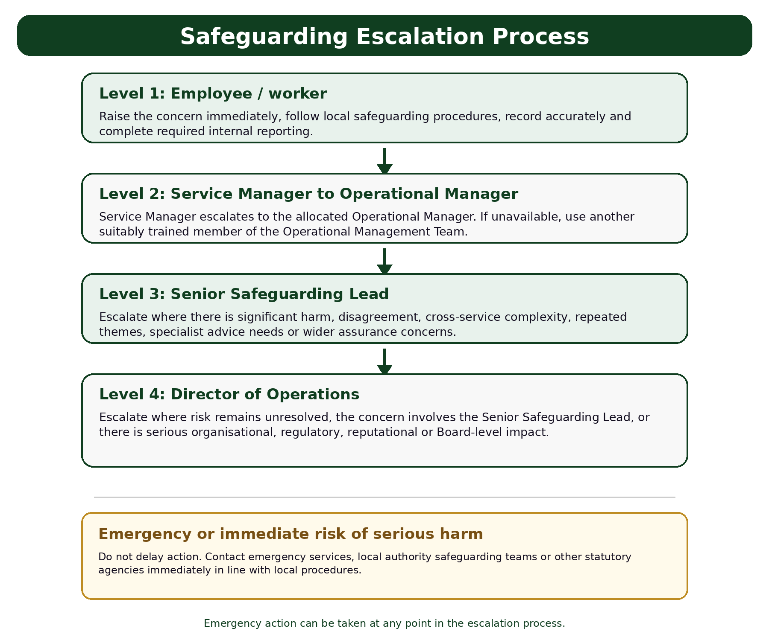
Figure: Safeguarding escalation process

- Regulatory Framework

  - When an allegation of abuse is made, the Line Manager must notify the appropriate commissioning body as contractually obliged. This may usually be either the local authority, Clinical Commissioning group (CCG), or the local NHS Foundation Trust.

  - In registered services where care is provided, employees must work in compliance with the Health and Social Care Act (Regulated Activities) Regulations 2010 and the CQC (Registration) Regulations 2009 and notify CQC as soon as possible of any of the following, in accordance with Regulation 18 (Outcome 20):- any serious injury occurs to a client deprivation of a person’s liberty, abuse or allegations of abuse, events that stop the service from carrying out a regulated activity safely and to the appropriate standard, incidents reported to or investigated by the police.

  - In addition, the Registered Manager must notify the CQC of any safeguarding concerns regardless of whether the safeguarding team decide to pursue the concern and regardless of any other organisation notifying CQC.

- Responsibilities of Inspire North Employees

  - Act to safeguard individuals.

  - Be attuned to the risk of neglect, harm or abuse of clients and raise concerns with their line manager.

  - Wherever and whenever employees have contact, in the course of their duties, with a person thought to be at risk of abuse or exploitation, then employees have a responsibility to act. Anyone can make a safeguarding referral. Doing nothing is not an option.

  - Work with partner agencies and share good practice.

  - Employees have a responsibility to ensure that no action or omission on their part would be detrimental to the safety of an adult at risk. Individual risk assessment profiles should be referred to as these may contain valuable information as to agreed action to manage any risks arising out of vulnerability.

  - The relationship between worker and client must be based on trust and respect for the individual. Employees must at all times be aware of the power imbalance within the relationship and must ensure that they do not embark upon or collude with any actions which would be interpreted as abusive.

  - Inspire North Boundaries Policy available on INsite gives clear guidance to employees in maintaining acceptable relationships with clients. Additionally, employees who are members of a professional body such as the NMC (Nursing and Midwifery Council) must also adhere to the professional code of conducts of those organisations. Please see Nurses Registration and Revalidation Policy also available on INsite.

- Management and supervision of employees

  - Employees will receive regular supervision meetings in line with the organisation Supervision policy. These will be recorded, and the notes agreed by both parties.

  - When an employee is involved in safeguarding issues, this will be reviewed within supervision i.e. recordings, assessments, monitoring arrangements etc. and decisions relating to the level of involvement will be taken by the appropriate person within the organisation.

  - When an employee is working with an adult who is subject to a safeguarding plan, discussion of the case will be a standing agenda item in supervision.

  - Supervisors will ensure that information about adults is appropriately shared with other organisations and that they will be informed if work ceases with the person.

  - Employees will be able to access ad hoc time for support if required.

  - In exceptional circumstances, external supervision may be granted at the discretion of SLT.

- Reporting Concerns – PIPOT

14.1 PIPOT (People in Positions of Trust) is the safeguarding process for adults, particularly those who are vulnerable or at risk. The framework ensures that any concerns about individuals in positions of trust who work with or have access to vulnerable adults are managed appropriately to protect them from harm.
14.2 Key Aspects of PIPOT Safeguarding for Adults
- Identification of Concerns:
Concerns may arise regarding individuals in positions of trust through various sources, including reports of abuse, inappropriate behaviour, breaches of professional boundaries, or other actions indicating a potential risk to vulnerable adults.

- Reporting Concerns:
  - Any concerns should be reported to the designated safeguarding lead (DSL) or a senior manager within the organisation where the individual works or volunteers.
  - The DSL or manager should refer the concern to the Local Authority Designated Officer (LADO) or the equivalent Adult Safeguarding Lead.

- Role of the LADO/Adult Safeguarding Lead:
  - The LADO or Adult Safeguarding Lead oversees and manages individual cases involving concerns about people in positions of trust.
  - They provide advice and guidance to employers and voluntary organisations, liaise with the police and other agencies, and monitor the progress of cases to ensure they are handled thoroughly and fairly.

- Initial Evaluation:
The LADO/Adult Safeguarding Lead conducts an initial evaluation to assess the nature of the concern and decide the appropriate action. This may involve:
    - Referring the matter to the police if there is a criminal element.
    - Conducting a safeguarding risk assessment.
    - Considering immediate actions required to protect vulnerable adults.

- Multi-Agency Strategy Meetings:
  - If the concern warrants further investigation, a strategy meeting may be convened. This involves representatives from relevant agencies, such as social services, the police, and the employer, to share information and plan actions.
  - The strategy meeting will consider whether the individual poses a risk, what immediate actions are necessary (such as suspension from duties), and what further investigations are needed.

- Investigation:
Depending on the outcome of the strategy meeting, an investigation may be conducted, which can involve:
    - Internal investigation by the employer.
    - Police investigation if a criminal offence is suspected.
    - Professional regulatory body investigation if the individual is a member of a regulated profession.
N.B While a police investigation is ongoing, internal investigations must not go ahead at the same time.
- Outcome and Actions:
The investigation outcome may lead to various actions, such as:
    - Disciplinary action by the employer.
    - Referral to a professional regulatory body.
    - Criminal prosecution.
    - Recommendations for training or other corrective measures.

- Recording and Monitoring:
  - Detailed records of the concern, investigation, and outcomes should be maintained to ensure transparency and accountability.
  - The LADO/Adult Safeguarding Lead monitors the progress of cases and ensures that they are resolved in a timely and appropriate manner.

- Support for Affected Parties:
Support should be provided for the individual who raised the concern, the person who is the subject of the concern, and any vulnerable adults affected by the situation.
14.3 PIPOT safeguarding processes are essential for protecting vulnerable adults by ensuring that concerns about individuals in positions of trust are managed effectively. Prompt reporting and adherence to the proper procedures help maintain the safety and well-being of vulnerable adults and uphold trust in the organisation working with them.

14.4 Useful Contacts and Resources
- Action on Elder Abuse: 0808 808 8141 - For advice and support regarding elder abuse.
- Local Authority Adult Safeguarding Team: Contact details can be found on the local council’s website.
- Safeguarding Adults Boards: Provide guidelines and procedures for safeguarding practices in local areas.
- Care Quality Commission (CQC): 03000 616161 - Regulatory body for health and social care services, which can also handle safeguarding concerns.

14.5 Key Resources
- Care Act 2014: Provides the legal framework for safeguarding adults, including the responsibilities of local authorities and other organisations. This Act has been updated with additional guidance in July 2025.
14.6 Implementing these safeguarding procedures helps ensure that concerns about people in positions of trust are addressed properly, protecting vulnerable adults from harm and maintaining trust in care and support services.

- Recording and managing confidential information

  - The referral must be stored in compliance with the Inspire North’s Information Governance Framework and Policies, and in line with The Data Protection Act 2018.

  - All employees hold a duty of confidentiality to all clients of Inspire North. This duty of confidentiality, however, is not absolute. All enquiries into the death of adults find that information sharing between professionals and agencies is essential if adults are to be safe.

- Management Reviews

  - Service managers will undertake management reviews of all safeguarding referrals. This will usually be done in team sessions where peer support can be accessed, and joint learning can occur. Any learning should be communicated to the Designated Safeguarding Officer.

- Disseminating and reviewing the policy and procedure

  - This policy will be disseminated through the Inspire North Leadership Forum and then to all teams. It will be reviewed by the Designated Safeguarding Officer annually, if legislation changes or following feedback regarding practical issues of implementation. An annual review of the effectiveness of this policy will be undertaken with employees via the relevant organisation.

APPENDIX A: Please Note – policy Snapshots are intended to give you all the essential information found within a policy, in one easily digestible chunk. They are not designed to replace the policy thus; all employees should ensure they are familiar with the full policy.

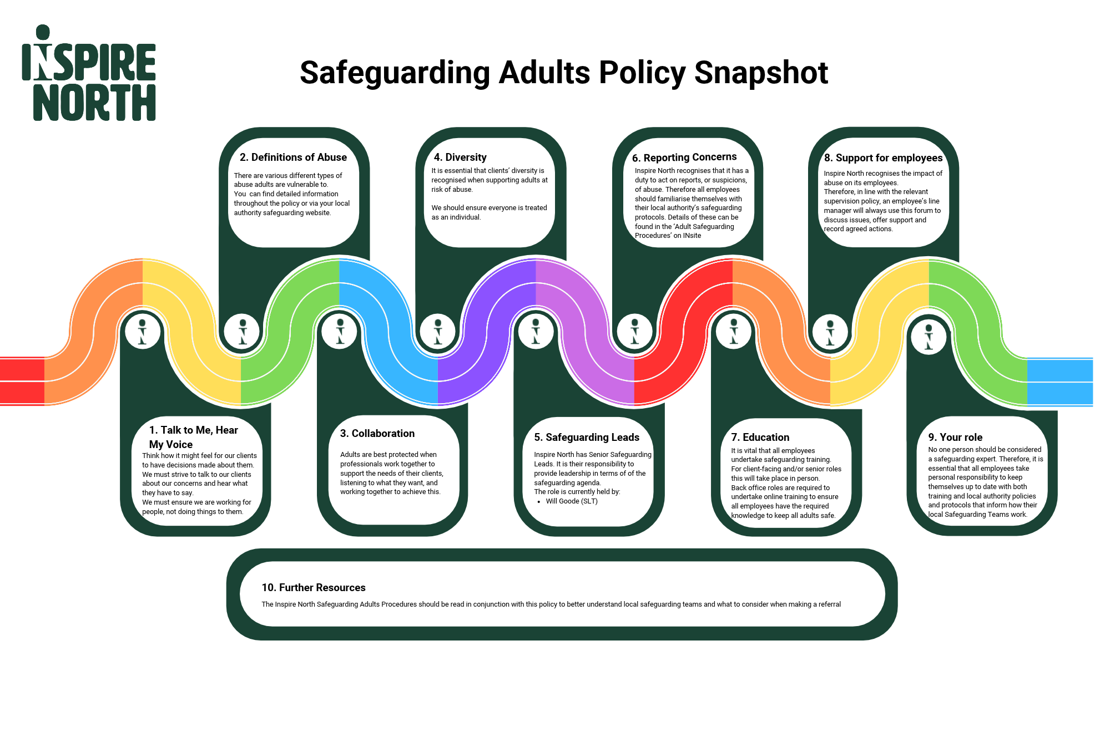

Appendix 2

Reporting a concern: Datix Reporting

Adding an incident: https://inspirenorth.gateway.prod-uk.datixcloudiq.co.uk/capture/?action=newdif1&module=INC

Local Authority Safeguarding Referrals:
When you need to inform Local Authority Safeguarding following an Incident, you can highlight this in Datix.
When reporting an Incident, you can select this from the below options on the form:

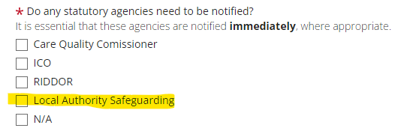

Selecting this option will open up a Safeguarding Section with the below questions:

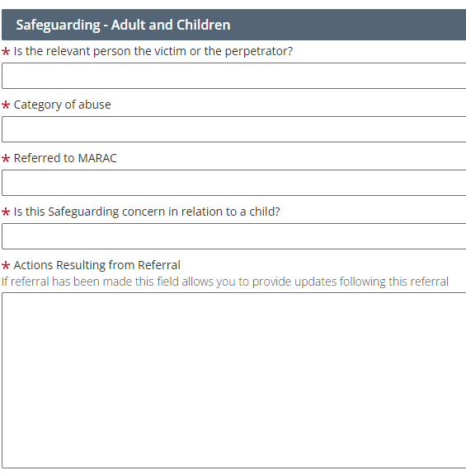

The bottom field above will allow us to understand what happened following referring to Local Authority Safeguarding – this can be updating as part of the review of the Incident and not just at Reporting of the Incident.

Equality Impact Assessment

As an organisation we need to ensure that all our strategies, policies, services and functions, both current and proposed have given proper consideration to equality and diversity. This links directly to our becoming anti-racist aspiration for our organisation.

It will be an exercise that determines relevance for all new and revised strategies, policies, services and functions. This screening process will provide a record of both the process and decision making.

It needs to be completed at the earliest opportunity and it will help to determine:
- the relevance of proposals and decisions to equality and diversity.
- whether or not equality and diversity are being or have already been considered.

Organisation: | Inspire North | Service: | Operations Team (CST)
Person undertaking the screening: | Ben Joslin | Email: | ben.joslin@inspirenorth.co.uk

- Title of what is being screened?
Strategy / Policy  ☒ |  |  | Service / Function  ☐ |  |  |  | Development  ☐
Other  ☐ |  |  | If other, please specify:
- Please provide a brief description of what you are screening?
Safeguarding Children – policy and procedures

- Relevance to equality and diversity

All of our developments, strategies, policies, and services affect clients, employees or the wider community or local communities. These will also have a greater or lesser relevance to equality and diversity.

The following questions will help you to identify how relevant your proposals are.

When considering these questions think about age, carers, disability, gender reassignment, ethnicity, religion or belief, gender and sexual orientation and also those areas that impact on or relate to equality.
Questions |  |  |  |  |  |  | Yes |  | No
Is there an existing or likely differential impact for the different equality characteristics? |  |  |  |  |  |  | ☐ |  | ☒
Have there been or likely to be any concerns about the project, policy or proposal? |  |  |  |  |  |  | ☐ |  | ☒
Could the proposal being screened affect how our services are provided and located? |  |  |  |  |  |  | ☐ |  | ☒
Could it impact on our strategies, policies and functions? |  |  |  |  |  |  | ☐ |  | ☒
Could the proposal affect our workforce or employment practices? |  |  |  |  |  |  | ☐ |  | ☒
Does the proposal involve or will it have an impact on;  - Eliminating unlawful discrimination, victimisation and harassment  - Advancing equality of opportunity  - Fostering good relations. |  |  |  |  |  |  | ☒ |  | ☐
If you have answered yes to any of the above and;
- Believe you have already considered the impact on equality, diversity, cohesion and integration within your proposal please go to section 4.
- Are not already considering the impact on equality, diversity, cohesion and integration within your proposal please go to section 5.

If you have answered no to the questions above, please complete sections 6 and 7
- Considering the impact of Equality and Diversity

- How have you considered equality and diversity?
I have considered all groups of people with various backgrounds and identities and how they can be impacted by safeguarding.
Specific information has been provided for female genital mutilation and
modern slavery.

- Key findings
The policy outlines the types of support and referral thresholds to statutory specialist and early intervention as well as key legislation to protect the rights of all vulnerable adults.
- Actions
This policy incorporates a diverse range of people from various backgrounds and characteristics. Any feedback during the dissemination period will be acknowledged and reviewed if any gaps or negative impact is identified.

5. If you have not already considered the impact on equality, diversity, cohesion and integration, you will need to carry out an impact assessment.
Date you will scope and plan you impact assessment: |  |  |  |  | Date you will complete the impact assessment:
Name and Job Title of person who will lead on the impact assessment:
6. Governance and approval
Please state here who has approved the actions and outcomes of the screening
Name: | Kira Moxon-Lumb |  |  | Job Title: |  | Director of Operations
Date Screening Completed: |  |  |  | Date Screening Approved:
7. Publishing Checklist
Please tick to confirm the following actions have taken place:
A copy of this screening form has been attached as an appendix to whatever it is that has been screened |  |  |  |  |  |  |  |  | ☒

