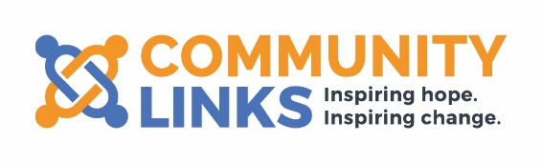

Trustee
Do you have some time to spare and a passion for making a difference?
We are looking for someone with a background in psychiatry to join our Group Board of Trustees to ensure we make our vision a reality.
In this role you will be part of the Community Links team and board meetings are held concurrently for the group.
We expect all of our Trustees are committed to our Equality, Diversity and Inclusion agenda as well as being able to support our organisations to become more anti-racist. We also want to increase the diversity of our Board in terms of ethnicity and sexual orientation and are looking for people who have drive, commitment, and innovation.
We welcome applications from people of all ages and those with lived experience of the issues our clients face.
If you are excited by our work, share our values and are willing to play an active part in the work of our Board, and want to be part of a Top 100 Company, we want to hear from you!
You will demonstrate an understanding of what it takes to deliver effective services, the ability to think strategically and be able to make good decisions.

You do not necessarily need previous board experience. You will receive a full induction and will be supported by other Board Members and the Chief Executive in your role.
You will need to be able to make a commitment of approximately three half days per quarter, have the ability to think creatively and a willingness to speak your mind. Please see attached role profile and application pack.

As a trustee, you will be instrumental in planning the strategic future of Inspire North and associated companies.

The board usually meets 4 times a year with 3 sub committees which also meet quarterly. Each Trustee sits on one of the sub-committees. Currently our meetings are held virtually. Potential trustees must be eligible in line with Charity Commission regulations which are available from www.charitycommission.gov.uk.

For an initial discussion please email Ruth Kettle, Chief Executive on ruth.kettle@inspirenorth.co.uk

Please send your completed application form to hrteam@inspirenorth.co.uk
Closing date: 5th June 2022
Our Head Office is based in Leeds, and we work across the North of England.

